A Comparative Study on Health Insurance and Hospital Utilization by Demographics

Navachandu Nadella, Priyanka Chowdary Mandava, Rohan Satya Isaac, Sakshi Shah, Swapna Ponduri, Yuva Naga Yasaswini Garneni

1Indiana University-Purdue University, Indianapolis, IN 46202, USA,

{ [nnadella, pmandava, risaac, sgshah, sponduri, ygarneni}](mailto:%20nnadella,%20pmandava,%20risaac,%20sgshah,%20sponduri,%20ygarneni%7d)@iu.edu

**Abstract.** Health Insurance in the United States has grown over the years such that today there more than 90% people who are covered with insurance. The majority of the population are covered by either a government program or through a private health insurance. It is crucial to understand how different demographics relate to different health insurance status and inturn the health care utilization. Past research has found particularly interesting insights on the relation of health care with certain demographic characteristics such as language and nativity. It is cited that further research is needed to identify patterns and improve overall health care utilization and health insurance coverage. In this project we undertook a detailed analysis of survey respondents data on their demographics, health insurance and health care utilization information. We tend to identify deeper insights through data analyses, cluster analysis and through machine learning techniques.

**Keywords:** Data Analyses, Health Insurance, Health Care Utilization, Demographics, Cluster Analyses, Machine Learning, Classification, Interpretation

1. Project Scope
   1. Introduction

The estimated population of the United States in 2020 was 326 million people. Most of those people had private health insurance or received medical treatment through a government program (such as Medicare or Medicaid). In the US, 8.6% of people lacked health insurance. In 2020, total health consumption expenditures (HCE) by individuals (including those without insurance), health insurers, and federal, state, and local governments totaled $3.9 trillion, or 18.8% of the country's GDP (Ryan J. Rosso) [2]. Research in this area also observes that a patient's demographics, particularly their financial situation, affects an individual’s capacity to get medical care through a health insurance system. (Lynne Moore) [3]. Given the healthcare domain has grown over the years it is important to analyze and extract crucial insights on how different demographics affect access to care and an individual’s health insurance status. Another study has found that even characteristics such as language and nativity play a key role in access to health care among United States Hispanics and it points for further study [4]. This motivates deeper investigation in obtaining more crucial and interesting insights using the NHANES survey respondent's data which is the focus of this project. Using the data at hand we tried to also understand the predictive power of a respondent's demographic factors on their health insurance status and health care utilizations levels. Additionally tested more features from the whole array of respondent’s information.

We also investigated and drew links regarding the factors impacting people's access to healthcare. According to statistics, 30 million Americans lack health insurance, and many of them change their insurance every year. In research, low-income patients who changed their coverage every year saw less continuity with physicians, changes in drug regimens, and negative consequences on the overall quality of care and health. This is known as churning, and it has substantial repercussions on patient health [1]. From our project we researched to identify what factors are affecting the health outcomes as well and tried to conduct a comparison as to how overall all these factors are related to each other.

* 1. Aim

We aimed to find out how socio demographic and economic aspects such as income, age, gender, race, and area relate to hospital visits and the status of health insurance an individual has. Draw pertinent and important insights from the data for example, if certain factors in the data influence health insurance status and health care utilization much more significantly than others. Use clustering algorithms like k-means, hierarchical clustering, and other clustering algorithms to find logical clusters within the data for advanced analysis. Through clustering we aimed to find clusters which show high variance between them, for instance a cluster that shows high utilization of health care while predominantly having no health insurance and vice versa. Clusters which group demographics of similar characteristics and their health care utilization levels. Use machine learning models like logistic regression, tree-based models, and neural network models to predict a person's health insurance availability as well as hospital utilization using their demographics information. The ability to predict accurately would help test our defined hypothesis. We aimed to find important factors through machine learning model interpretation methods as well.

* 1. Purpose

The purpose of the study is to,

* Determine whether those who match specific socioeconomic requirements can be related to their health care utilization levels and health insurance status. If so, what sort of insurance do they have? Identifying these aspects can help curate specific insurance plans for specific demographics.
* Whether respondents can be grouped into separate clusters of similar characteristics, be labelled, and studied deeper. In general, to bring out insights in lines with the research paper on Community demographics and access to health care among U.S. Hispanics [4] which talks about how characteristics such as language and nativity also play a key role in access to health care among United States Hispanics
* Predict a respondent's hospital utilization status and their health insurance status using their demographics information. If we can predict with good accuracy this would allow us to target people with no insurance and get them covered.
* Understand the demographic factors which have a significant impact in determining their health insurance status and health care utilization levels. Try to understand deeper why certain factors affect more and if we can identify any incorrect notions in society using these factors.
  1. Research Questions

The research questions are broken down and hypothesized. The research questions are listed down below,

Null Hypothesis:

* There are no significant associations between health insurance and hospital utilization when compared across demographics for the survey respondents. The demographic factors of respondents do not affect their health insurance status and their health care utilization. We cannot accurately predict health insurance status and health care utilization levels with demographics information of the respondents.
* There are no meaningful groups of clusters across the data that can be identified, and they do not vary much. For example, we do not find insightful clusters where it groups similar demographics together which have a similar relationship with health care utilization and insurance. This in turn does not provide any deeper insights into respondent characteristics
* No identifiable factors which have a significant impact on predicting health care utilization outcomes and health insurance status outcomes. We cannot find interesting patterns within the respondents' data based on specific factors.

Alternate Hypothesis:

* There is a significant association between health insurance and hospital utilization when compared across demographics for the survey respondents. The demographic factors of respondents affect their health insurance status and their health care utilization. We can accurately predict health insurance status and health care utilization levels with demographics information of the respondents.
* There are meaningful groups of clusters across the data that can be identified, and they do vary. For example, we do find insightful clusters where it groups similar demographics together which have a similar relationship with health care utilization and insurance. This in turn provides deeper insights into respondent characteristics
* Identifiable factors have a significant impact on predicting health care utilization outcomes and health insurance status outcomes. We can find interesting patterns within the respondents' data based on specific factors.

1. Methodology
   1. Type of study

The type of study undertaken in the project are Qualitative and Quantitative in nature. Descriptive and Inferential statistics wherever necessary is employed.

* 1. Project Steps

The main objective of the project is to perform a comparative study between factors like people demographics, health insurance coverage, and hospital utilization levels using survey respondents’ data. We employ tools like Python, SQL and techniques for data analysis, visualization, and machine learning.

The methodology of our project involves:

1. Data Collection
2. Data Extraction
3. Data Cleaning
4. Data Merging
5. Exploratory Data Analysis
6. Data Clustering
7. Predictive Modeling
   1. End To End Project Flow

We depict the end-to-end project workflow through the following flow chart. We use Python and MySQL database through the project. MySQL database forms the main storage component of the project. In each step (notebook) we download the data from MySQL database and after performing the required operations we upload the data back to MySQL database.

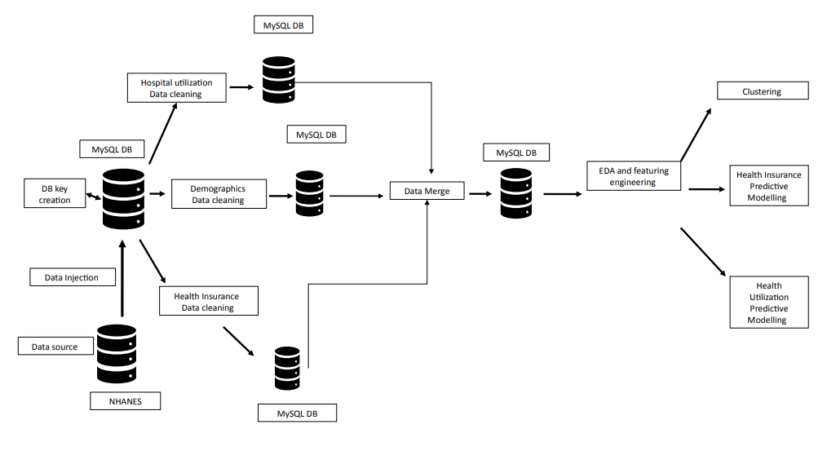

* 1. Planned Team Members and Responsibilities

Our team members come from Health Informatics and Applied Data Science backgrounds. The table below illustrates the list of team members at the start of the project and the planned responsibilities.

|  |  |  |
| --- | --- | --- |
| Name | Background | Responsibilities |
| Navachandu Nadella | Bachelor of Dental Surgery , Experience in Python and SQL intermediate level | Data Collection and Cleaning, Project Presentation |
| Priyanka Chowdary Mandava | Bachelor of Medicine and Bachelor of Surgery (MBBS), Basic experience in SQL and Python. | Data Collection and Cleaning, Project Presentation |
| Rohan Satya Isaac | Bachelor of Mechanical Engineering, Python, R, SQL, and Machine Learning Expertise | Project Management, Data Loading, Data Merging, Predictive Modeling |
| Sakshi Shah | Bachelor of Dental Surgery, Experience with Python and SQL intermediate level. | Exploratory Data Analysis, Project Presentation |
| Swapna Ponduri | Bachelor of Pharmacy, Beginner in SQL and Python. | Exploratory Data Analysis, Project Presentation |
| Yuva Naga Yasaswini Garneni | Doctor of Pharmacy (Pharm. D), Experience with Python and SQL intermediate level. | Exploratory Data Analysis, Project Presentation |

* 1. Actual Contributions from Individual Team Members

We were able to keep up with most of the planned responsibilities. Minor changes in tasks were made based upon the skillsets and availability, allowing the project to be finished on time.

|  |  |  |
| --- | --- | --- |
| Name | Background | Responsibilities |
| Navachandu Nadella | Bachelor of Dental Surgery , Experience in Python and SQL intermediate level | Data Collection and Cleaning, Project Presentation, Project Report |
| Priyanka Chowdary Mandava | Bachelor of Medicine and Bachelor of Surgery (MBBS), Basic experience in SQL and Python. | Data Collection and Cleaning, Project Presentation, Project Report |
| Rohan Satya Isaac | Bachelor of Mechanical Engineering, Python, R, SQL, and Machine Learning Expertise | Project Management, Data Loading, Data Merging, Predictive Modeling, Project Report |
| Sakshi Shah | Bachelor of Dental Surgery Experience with Python and SQL intermediate level | Exploratory Data Analysis, Project Presentation, Project Report |
| Swapna Ponduri | Bachelor of Pharmacy,  Beginner in SQL and Python. | Exploratory Data Analysis, Project Presentation, Project Report |
| Yuva Naga Yasaswini Garneni | Doctor of Pharmacy (Pharm. D), Experience with Python and SQL intermediate level. | Data Cleaning, Exploratory Data Analysis, Project Presentation, Project Report |

* 1. Project Challenges

In any project there are always challenges and so was in ours.

We faced challenges in the data cleaning phase. Most of the values in our data are categorical and had missing values for the survey responses. We had to ensure that each column was cleaned appropriately and free of null values.

The team was new to a complete end to end data analytics project. At times it became difficult to solve technically complex problems. This would include technical aspects related to data storage such as uploading and extracting data, Python programming and Machine Learning implementations.

Selection of the right clustering algorithm for the data at hand was challenging. The team worked on more than one algorithm, labeled the clustered and calculated silhouette scores. Identifying the right labels was difficult as the clustered groups needed to be looked at individually and compared with other clusters.

In predictive modeling we encountered imbalanced classes in our target variables. Imbalanced data is generally an issue when it comes to achieving good predictive power. After trial and error with sampling methods the recall scores were up. More experimentation was done such as hyperparameter tuning, threshold optimization, feature engineering to increase recall scores to acceptable levels.

1. Data Collection
   1. Data Source

* Demographic Information
  + Data Link: <https://wwwn.cdc.gov/nchs/nhanes/search/datapage.aspx?Component=Demographics&Cycle=2017-2020>
  + Data File Name: Demographic Variables and Sample Weights
  + Data dictionary Link: <https://wwwn.cdc.gov/Nchs/Nhanes/2017-2018/P_DEMO.htm>
* Health Insurance Data
  + Data Link: <https://wwwn.cdc.gov/nchs/nhanes/search/datapage.aspx?Component=Questionnaire&Cycle=2017-2020>
  + Data File Name: Health Insurance
  + Data dictionary Link: <https://wwwn.cdc.gov/Nchs/Nhanes/2017-2018/P_HIQ.htm>
* Hospital Utilization Data
  + Data Link: <https://wwwn.cdc.gov/nchs/nhanes/search/datapage.aspx?Component=Questionnaire&Cycle=2017-2020>
  + Data File Name: Hospital Utilization & Access to Care
  + Data dictionary Link: <https://wwwn.cdc.gov/Nchs/Nhanes/2017-2018/P_HUQ.htm>
  1. Data Description

The National Health and Nutrition Examination Survey (NHANES) is a series of studies conducted in the United States to measure the health and nutritional status of adults and children and the survey is distinctive in that it combines physical examinations and interviews. The NHANES interview contains questions about demographics, socioeconomics, diet, and health. We will be using hospitalization, health insurance coverage and demographic data which consists of access to health care, hospital care history, covered by insurance, how long since last insured, time when no insurance and gender, age, country, marital status, respectively.

Demographic Information:

Number of features: 29

Link to Complete Data Dictionary: <https://wwwn.cdc.gov/Nchs/Nhanes/2017-2018/P_DEMO.htm>

Notable features:

**Note: Bolded Variables are Target Variables; Others Independent Variables**

|  |  |
| --- | --- |
| **Variable Name** | **Description** |
| RIAGENDR | Gender |
| RIDAGEYR | Age in years at screening |
| RIDRETH1, RIDRETH3 | Race/Hispanic origin |
| DMDBORN4 | Country of birth Adults 20+ |
| DMDYRUSZ | Length of time in US |
| DMDEDUC2 | Education level |
| DMDMARTZ | Marital status |
| SIALANG | Language of Interview |
| INDFMPIR | Ratio of family income to poverty |

Hospital Utilization Data:

Number of features: 7

Link to Complete Data Dictionary: <https://wwwn.cdc.gov/Nchs/Nhanes/2017-2018/P_HUQ.htm>

Notable features:

**Note: Bolded Variables are Target Variables; Others Independent Variables**

|  |  |
| --- | --- |
| **Variable Name** | **Description** |
| HUQ010 | General health condition |
| HUQ030 | Routine place to go for healthcare |
| **HUQ051** | **No. times receive healthcare over past year** |
| HUQ071 | Overnight hospital patient in last year |
| HUQ090 | Seen mental health professional/past yr |

Health Insurance Data:

Number of features: 14

Link to Complete Data Dictionary: <https://wwwn.cdc.gov/Nchs/Nhanes/2017-2018/P_HIQ.htm>

Notable features:

**Note: Bolded Variables are Target Variables; Others Independent Variables**

|  |  |
| --- | --- |
| **Variable Name** | **Description** |
| **HIQ011** | **Covered by health insurance** |
| HIQ032A | Covered by private insurance |
| HIQ032B | Covered by Medicare |
| HIQ270 | Do plans cover prescriptions? |
| HIQ032D | Covered by Medicaid |
| HIQ210 | Time when no insurance in past year? |
| HIQ032D | Covered by Medicaid |
| HIQ210 | Time when no insurance in past year? |

1. Data Storage and Extraction

There were three survey respondent datasets extracted from the NHANES survey repository namely Demographics, Hospital Utilization and Health Insurance Coverage. These form the core datasets. They were extracted and uploaded to the MySQL database server.

We have two extraction operations in our Project.

* Extraction of data from NHANES
* Extraction of data from MySQL Database
  1. Data Extraction

### Extraction From NHANES

The NHANES survey repository has data stored in XPT format. We download the files and use Python to convert the files to CSV format files using the Pandas Library functions. This helped us view the data through Microsoft Excel.

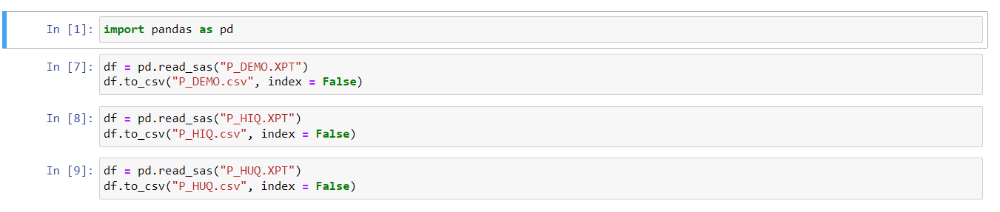

### Extraction From MySQL

To extract data from MySQL database to the Python environment we create a database connection using the library MySQLdb and use the connection instance to the Pandas library function read_sql to extract the data to a pandas data frame object



* 1. Data Import

To import data to MySQL database we appropriately convert all columns to the right datatypes and create a connection string using the function create_engine from the library sqlalchemy. Pandas library function to_sql is utilized to upload the data frame to MySQL database. The function uses the connection string as an input.

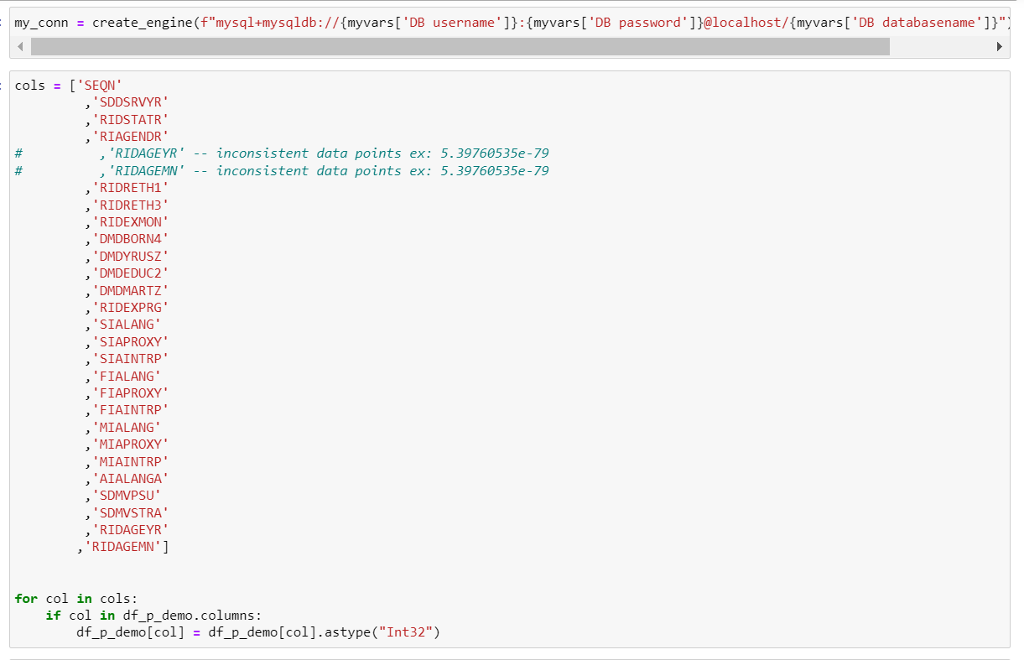

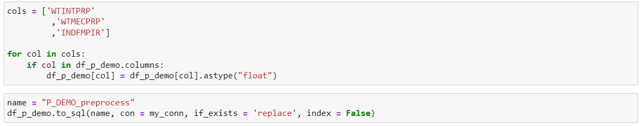

1. Data Cleaning

The datasets were obtained from the NHANES (National Health and Nutritional Survey). Data cleaning was carried out separately for each of the three datasets. Using related columns, logical possibilities, and the K Nearest Neighbours approach, the missing values in each field were imputed.

* 1. Demographics Data Cleaning

For the variables in this dataset, the values 7,9,77, 99 were converted to none as they belong to the classes “refused” (7,77) and “don’t know” (9,99). This applied to all columns in the dataset

Each column was separately treated. We use a table below to depict the method in which each individual column was treated.

The imputed demographic dataset variables,

|  |  |
| --- | --- |
| Demographic data | |
| Column | Imputation logic |
| RIDAGEYR | RIDAGEYR (represents age in years) multiply RIDAGEMN by 12 |
| DMDYRUSZ | DMDYRUSZ(represents no. of years the participant has lived in US), missing values imputed as separate class indicating people born in the U.S |
| DMDEDUC2 | DMDEDUC2(represents level of education completed by adults 20 and above) missing values imputed as separate class indicating people below 20 years of age |
| DMDMARTZ | DMDMARTZ(represents people's marital status) missing values imputed as separate class indicating people below age of 20 |
| RIDEXPRG | RIDEXPRG(represent women's pregnancy status) missing values imputed as separate class indicating males. |
| INDFMPIR | INDFMPIR( represent the ratio of family income to poverty) missing values imputed by KNN algorithm. |

* 1. Hospital Utilization Data Cleaning

For the variables in this dataset, the values 7,9,77, 99 were converted to none as they belong to the classes “refused” (7,77) and “don’t know” (9,99). This applied to all columns in the dataset

Each column was separately treated. We use a table below to depict the method in which each individual column was treated.

The imputed hospital utilization dataset variables,

|  |  |
| --- | --- |
| Hospital Utilization data | |
| Column | Imputation logic |
| HUQ071 | HUQ071(represents overnight hospital patients in past year) missing values imputed to value 2 who did not visit a mental health professional |

* 1. Health Insurance Data Cleaning

For the variables in this dataset, the values 7,9,77, 99 were converted to none as they belong to the classes “refused” (7,77) and “don’t know” (9,99). This applied to all columns in the dataset

Each column was separately treated. We use a table below to depict the method in which each individual column was treated.

The imputed health insurance dataset variables,

|  |  |
| --- | --- |
| Health Insurance Coverage data | |
| Column | Imputation logic |
| HIQ032A | HIQ032A (represents people who are covered by private insurance) missing values imputed to a different class who do not have private insurance. |
| HIQ032B | HIQ032B (represents people who are covered by medicare) missing values imputed to a different class who do not have medicare insurance. |
| HIQ032C | HIQ032C (represents people who are covered by Medi-Gap) missing values imputed to a different class who do not have Medi-Gap. |
| HIQ032D | HIQ032D (represents people who are covered by Medicaid) missing values imputed to a different class who do not have Medicaid. |
| HIQ032E | HIQ032E (represents people who are covered by Chip) missing values imputed to a different class who do not have CHIP insurance. |
| HIQ032H | HIQ032H (represents people who are covered by state- sponsored health plan) missing values imputed to a different class who do not have state- sponsored health plan. |
| HIQ032I | HIQ032I (represents people who are covered by government insurance) missing values imputed to a different class who do not have government insurance. |
| HIQ270 | HIQ270 (represents if insurance covers prescription) missing values are imputed to a different class who do not have insurance and 2 rows have been removed as it represents people who are covered by insurance, but their insurance does not cover by prescription. |
| HIQ210 | HIQ210 (represents time when no insurance in past year) missing values are imputed to a different class who do not have insurance |

1. Exploratory Data Analysis
   1. Data Overview:

### Gender Bar Chart

We want to see the distribution of men and women in the population and hence we are trying to plot a graph for the same.

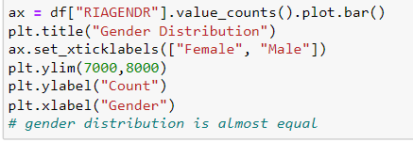

Figure: Code to plot a graph for gender distribution.

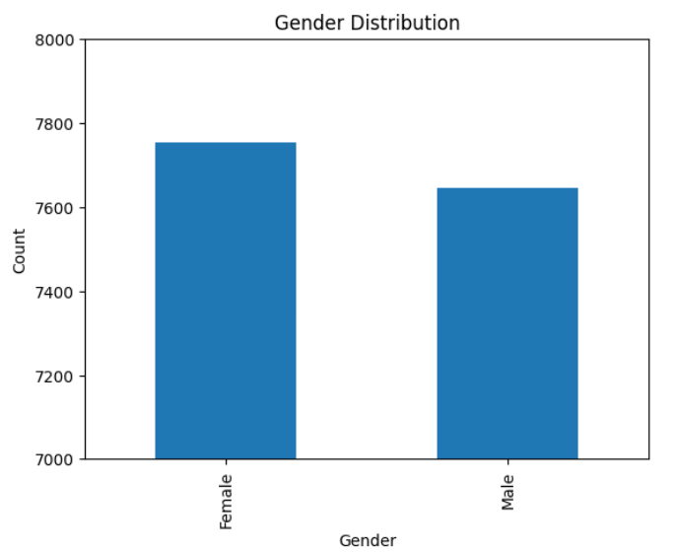

Figure: The graph demonstrates that there are more females than males.

### Age distribution chart

We want to see the distribution of respondents according to their age group by plotting a bar chart.

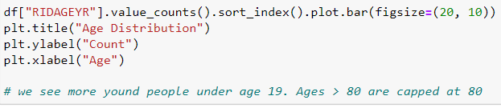

Figure: The above code is used to plot a graph for age distribution

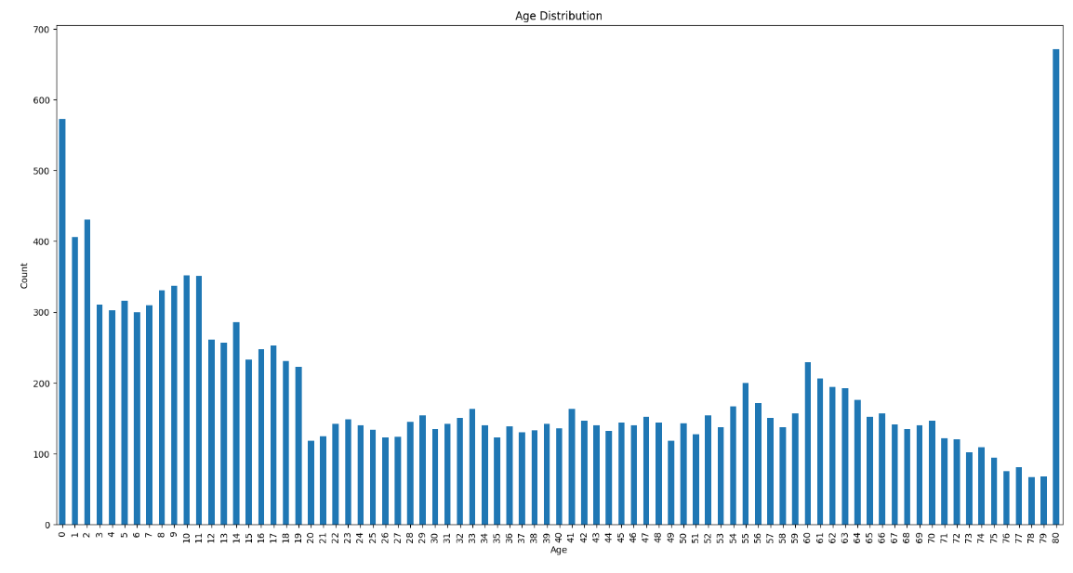

Figure: The bar chart represents the distribution of respondents according to age group.

The bar chart shows the distribution of people according to age groups. Majority of the respondents are below the age of 20 according to the representation. The values are capped at 80.

### Race Distribution graph

We wanted to plot a graph to show the distribution of people according to the races.

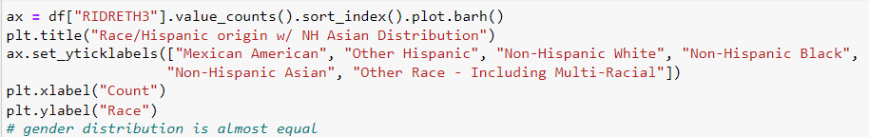

Figure: The above code is used to plot a graph for distribution of people according to races.

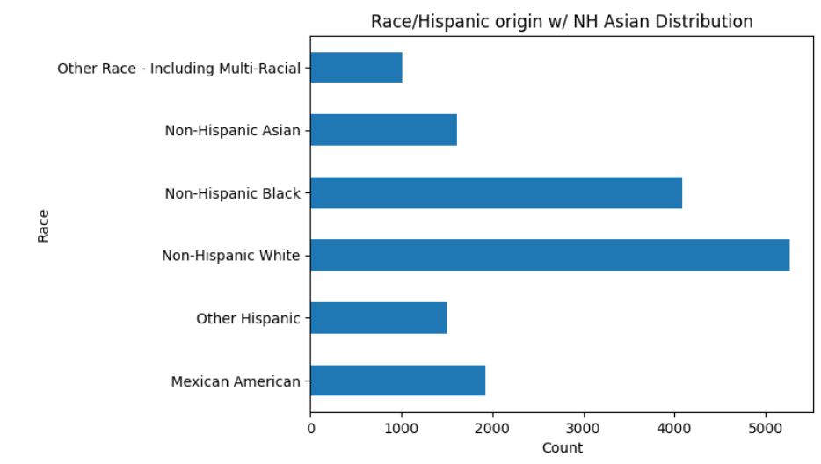

Figure: The bar chart shows the distribution of respondents according to their races. Through the graph we can infer that majority of people are Non-Hispanic White followed by Non-Hispanic Black.

### Distribution according to country origin graph

We wanted to plot a graph to show the distribution of people by country of birth.

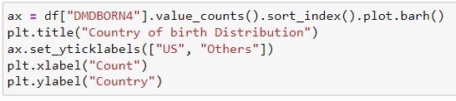

Figure: The above code is used to plot a graph to check how people are distributed according to their country of origin.

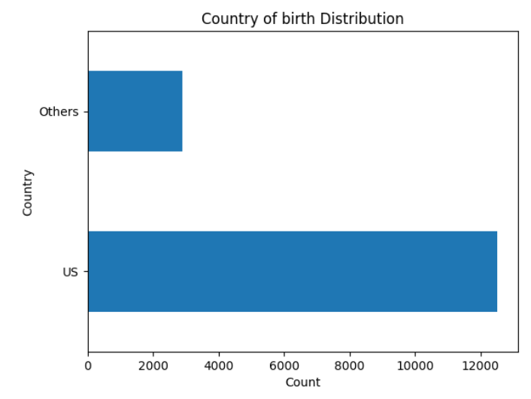

Figure: The graph shows distribution of respondents according to their country of birth. The chart shows the distribution of people based on country of birth. Through the graph we can infer that most of the people reside in the U.S.

### Ratio of family income to poverty chart

We are trying to check the distribution of the family income to poverty ratio by plotting a graph.

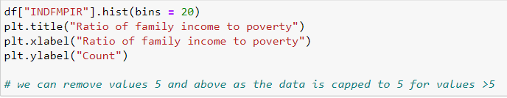

Figure: The above code is used to plot a distribution graph of ratio of family income to poverty.

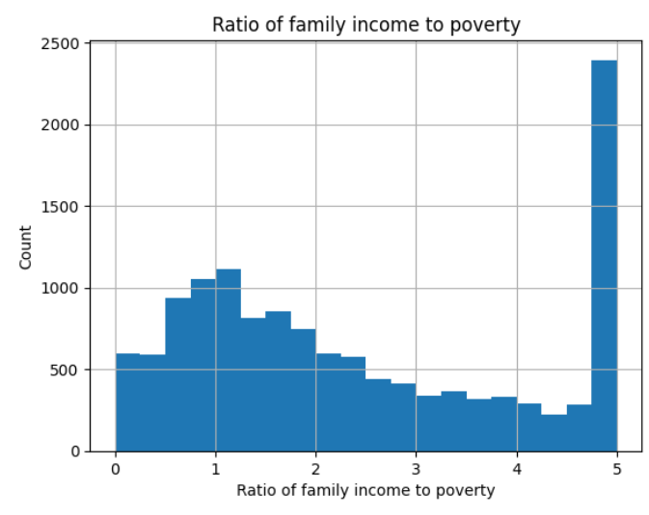

Figure: The graph is to show the distribution of people according to ratio of family income to poverty. The values are capped at 5. We see most of the family's income to poverty ratio near 0 to 2.

* 1. Insights
     1. Country of birth VS Race bar chart

We want to check the distribution of races according to their country of birth by plotting a graph.

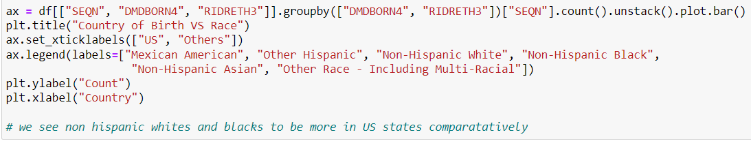

Figure: The above code is to plot a bar graph to represent the distribution of different races according to their country of birth.

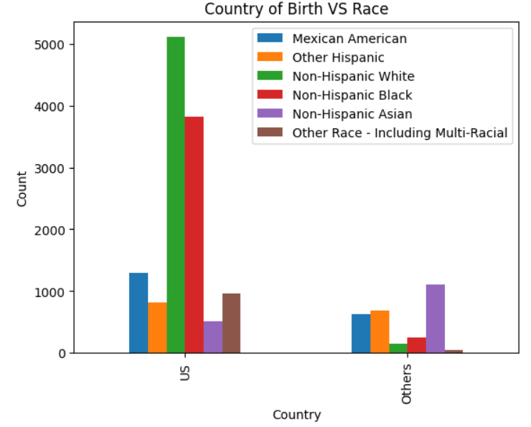

Figure: The bar graph shows distribution of races according to the country of birth. Through the graph we can infer that in US- Non-Hispanic White are in majority whereas in other countries Non-Hispanic Asians are in more number.

### Length of time in U.S

We want to plot a graph to see the distribution of respondents according to their length of stay in U.S

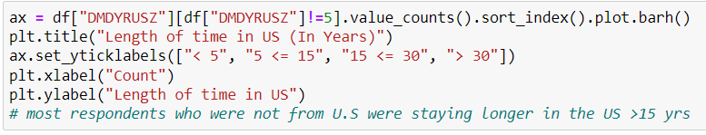

Figure: The above code is to plot a graph to see people’s length of time in U.S

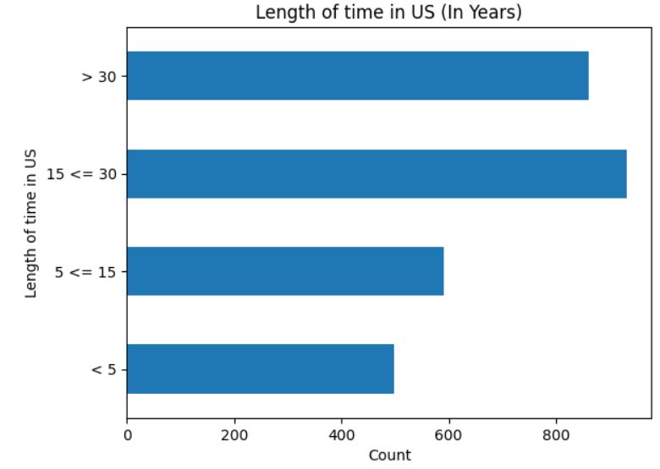

Figure: The bar chart represents people’s length of time in U.S. It can be seen that most of the people are staying more than 15 years but less than or equal to 30 years.

### Data distribution

We want to see the distribution of our data by plotting a graph using Fitter package

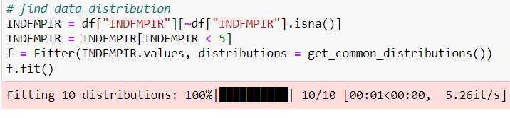

Figure: The above code is used to check the distribution of our data.

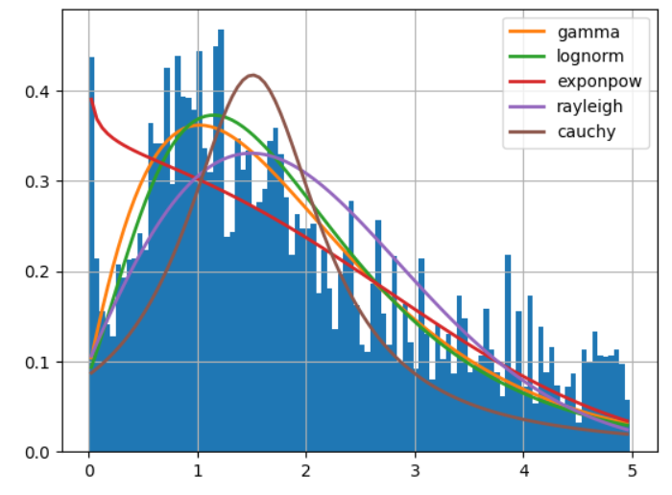

Figure: The graph above shows the data distribution. Through it we can infer that our data has a gamma distribution.

### Health care utilization vs health insurance

To determine the respondents' hospital utilization patterns and whether they have insurance or not, we wish to create a graph.

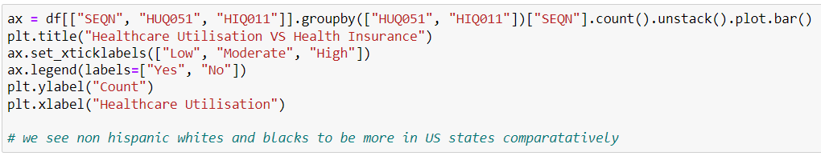

Figure: Plotting a graph of patient hospital utilization versus health insurance is done using the aforementioned code.

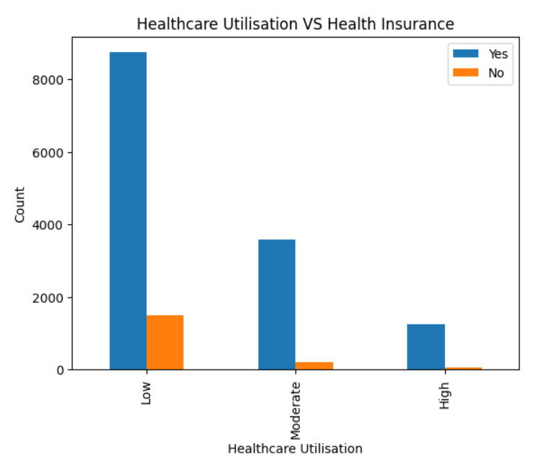

Figure The distribution of respondents according to their level of health care utilization—low, moderate, or high—as well as whether they have insurance or not is shown in a bar chart.

The chart indicates that the majority of respondents have low utilization rates with no insurance.

### Health utilization VS Gender

We want to plot a graph to check the utilization of hospitals of respondents on basis of their gender.

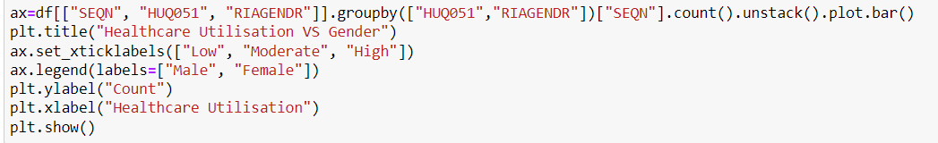

Figure: The code above is used to produce a graph showing respondents' hospital utilization (low, moderate, and high) according to gender.

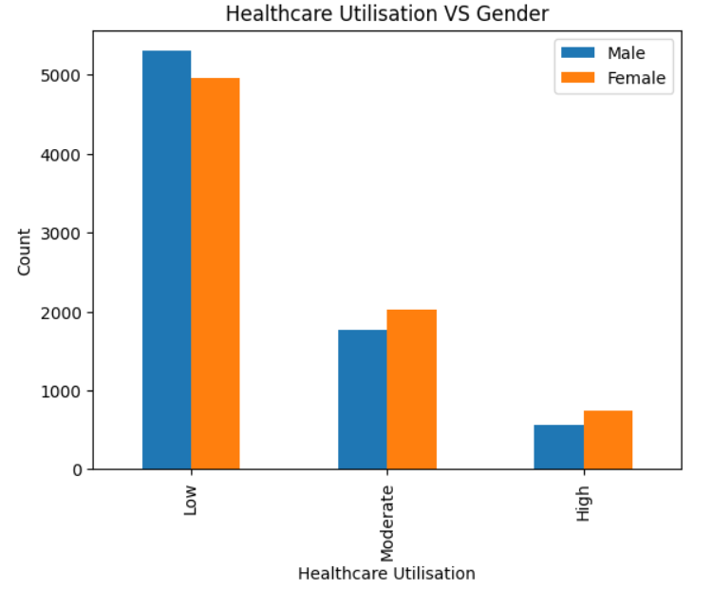

Figure: The use of respondents according to their gender is depicted in the graph above. The graph indicates that hospitals see a majority of male and female patients who have low hospital use rates.

### Healthcare utilization VS Race

We want to create a graph that shows how the respondents' use of healthcare varies according to their race.

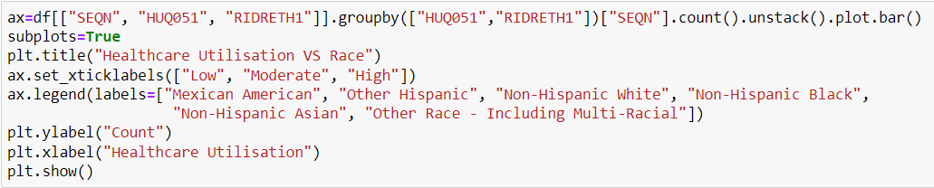

Figure: The code above will plot a graph showing respondents' hospital utilization by race.

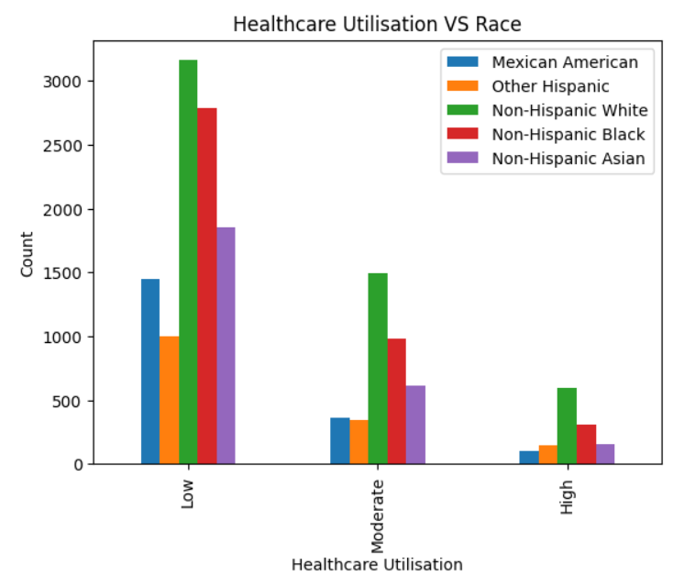

Figure: The distribution of respondents' hospital use (Low, Moderate, and High) by race is depicted on the graph.

The graph shows that in areas with low hospital utilization, Non-Hispanic White respondents make up the majority, followed by Non-Hispanic Black respondents. The same is evident for high and moderate consumption. Mexican Americans make up the least number of Hispanics in areas with high healthcare usage, compared to areas with low and moderate healthcare utilization.

### Health care utilization VS Marital Status

We want to create a graph to show how the respondents' use of healthcare varies based on their marital status.

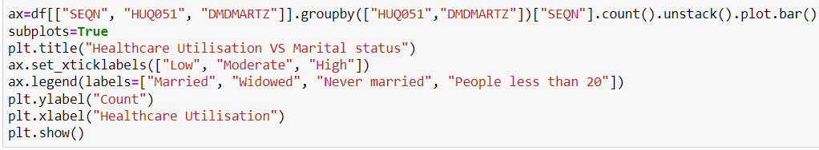

Figure: The code above is used to graph respondents' health care usage in relation to their marital status.

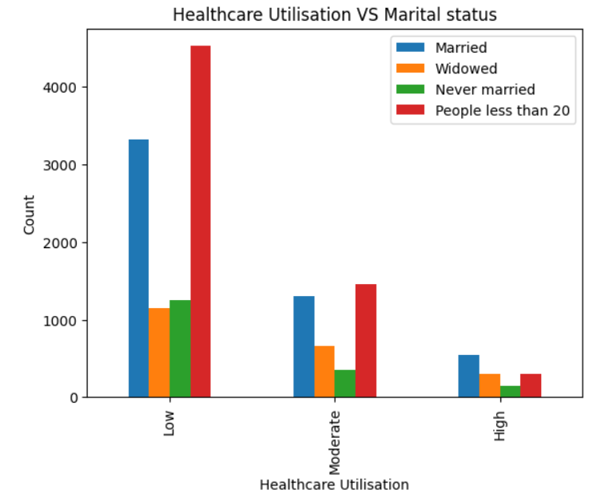

Figure: The distribution of respondents based on their healthcare usage by marital status is shown in the bar chart.

Through the graph, we can deduce that persons who use healthcare services infrequently are typically younger than 20 years old, whereas married individuals use healthcare services most frequently.

### Health Insurance VS Gender

To examine the distribution of respondents based on the criteria of having insurance or not and gender, we wish to create a graph.

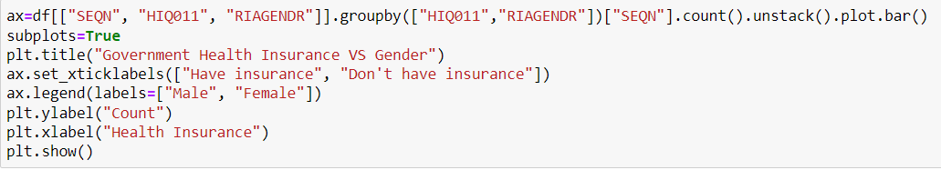

Figure: The code above is used to create a graph of individuals based on their insurance coverage by gender.

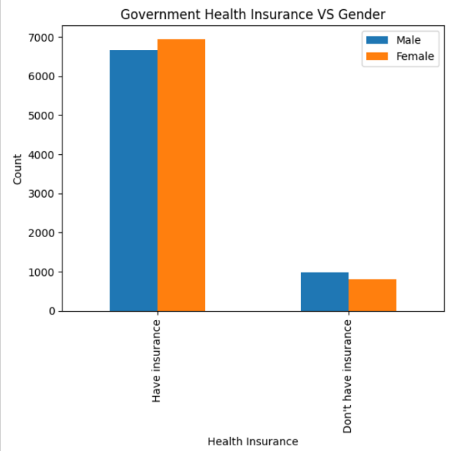

Figure: The bar graph shows how people are distributed according to their gender and whether they have insurance or not. We can deduce from the graph that men and women make up the majority of those with insurance.

### Health Insurance VS Race (Stacked graph)

To display the distribution of persons by race and whether they have insurance or not, we want to create a graph.

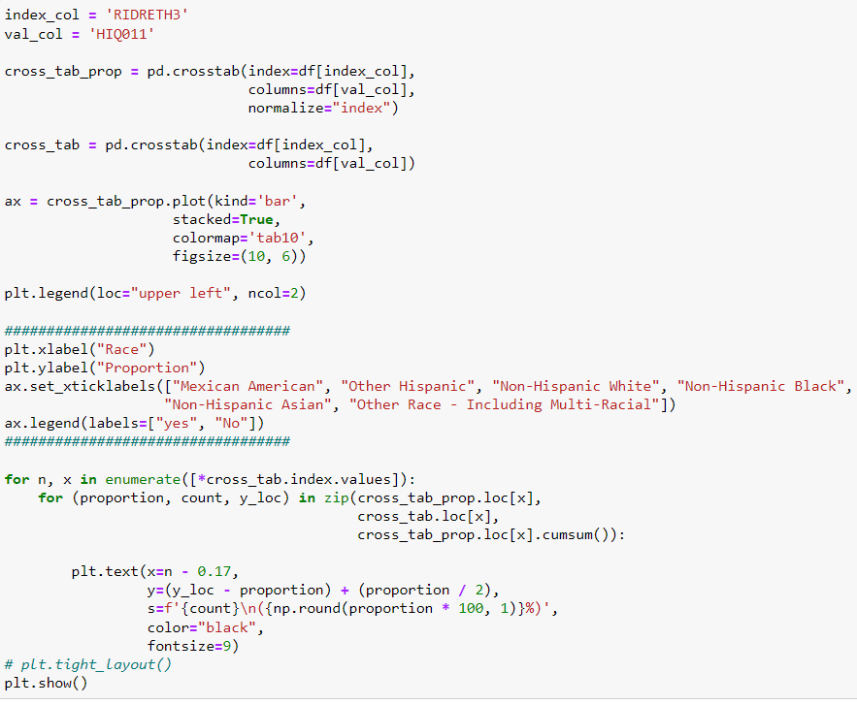

Figure: The aforementioned code is used to generate a stacked bar chart that shows how different races are distributed according to insurance coverage.

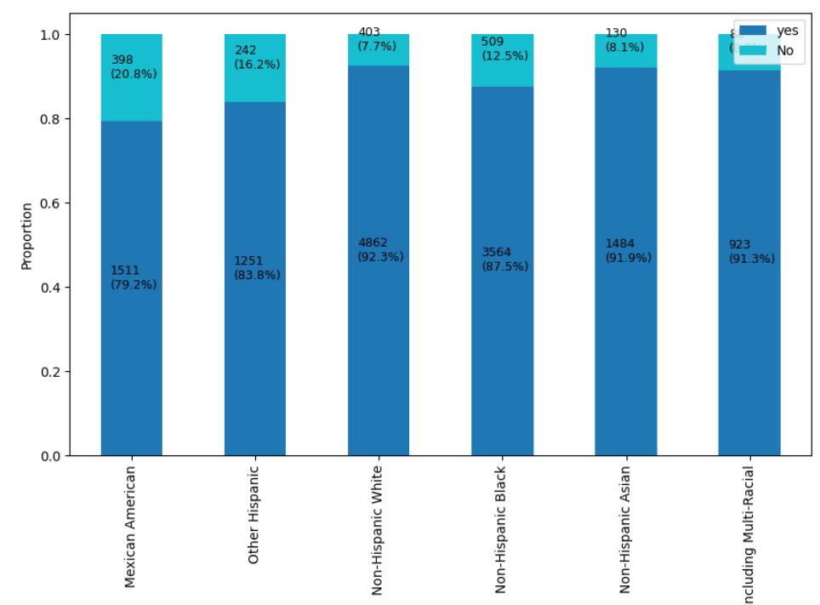

Figure: The distribution of various races in relation to insurance coverage is shown using a stacked bar chart. This graph indicates that Mexican Americans make up the majority of those without health insurance.

### Health Insurance VS Marital status

We want to check that health insurance distribution of people according to their marital status.

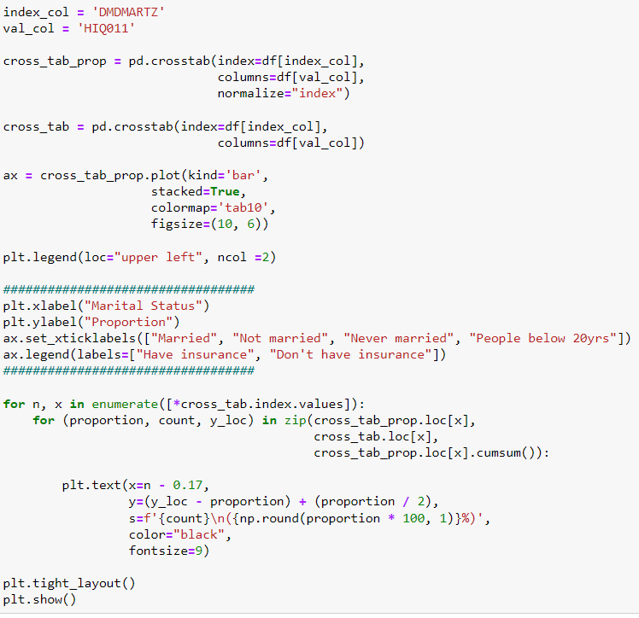

Figure: The code above is to plot a stacked bar graph to see the distribution health insurance of people on basis of their marital status.

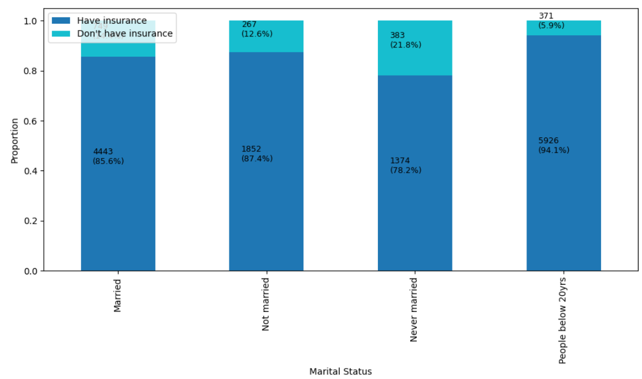

Figure: The bar graph displays the distribution of persons according to their marital status and access to insurance. We may deduce from the graph that those under 20 have the highest percentage of insurance coverage, while those who have never been married have the lowest.

* 1. Correlation Among Attributes

We are trying to find correlation between variables by plotting a Heat map using Dython package. We have used “Cramers-V” to calculate the correlation between categorial variables. Our target variables are Health Insurance (HIQ011) and Hospital utilization (HUQ051)

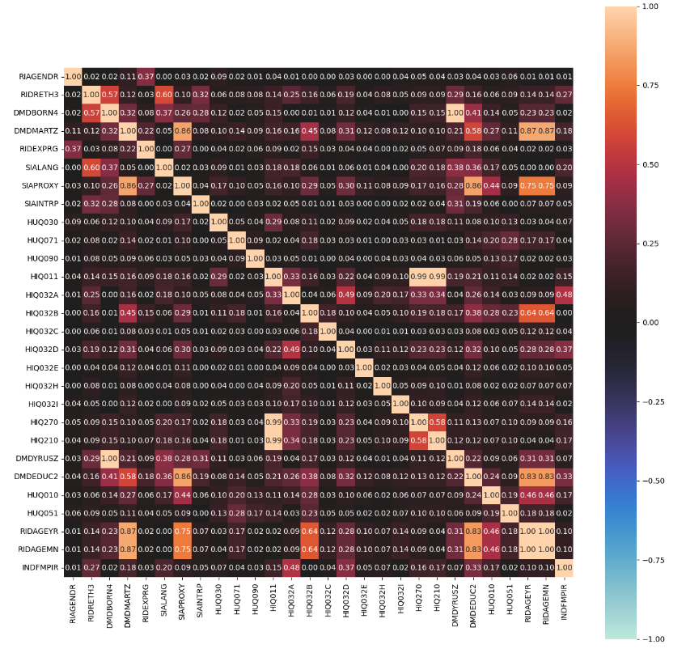

Figure: Representation of Heat Map to check the correlation of variables.

Through the above map we can see some relation between HIQ011(Covered by Health Insurance and HUQ030(Routine place to go for healthcare) and HUQ051(time received healthcare over past year) and HIQ032B(Covered by Medicare)

* 1. Statistical Tests

Statistical tests were performed to check the relative significance of the feature with the target variables. The following tests were performed

* Test for Normality
* Chi Square Test
* Kruskal Wallis Test
* Post Hoc Dunn Test
* Mann Whitney U Test

We separate the variables into the below categories as nominal, ordinal and continuous

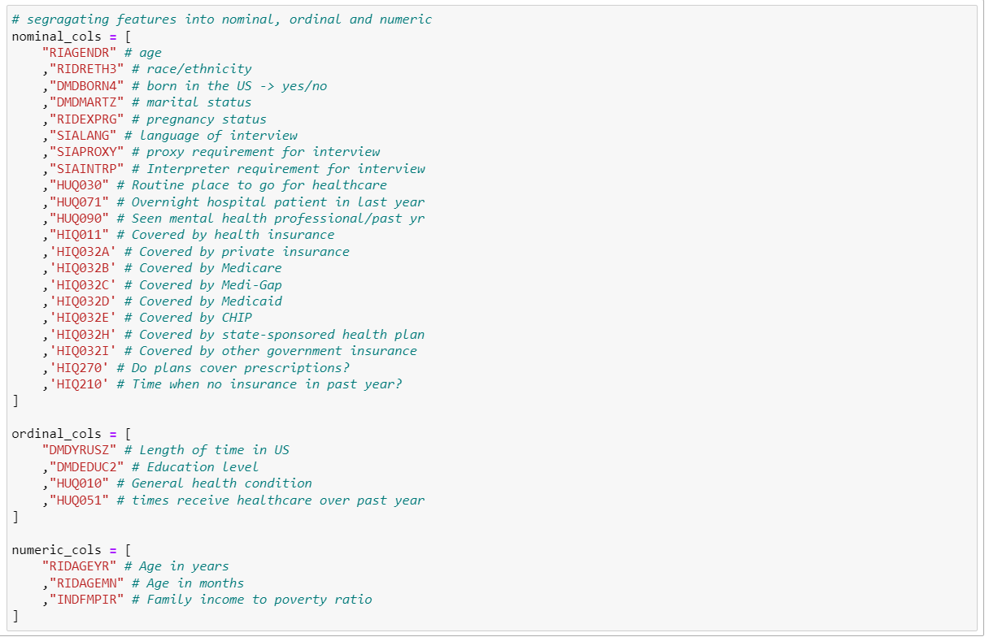

### Test for Normality

We performed a test of normality for the continuous variables in our dataset

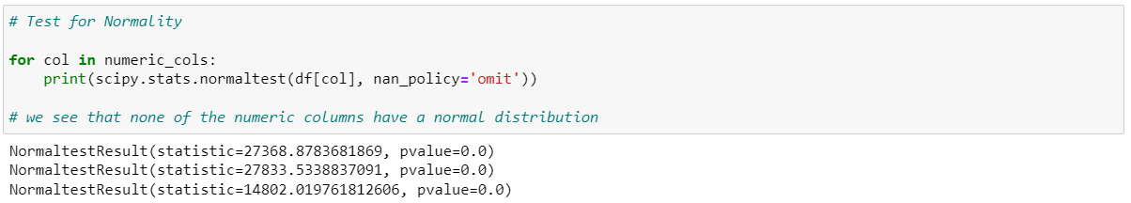

We observed none of the continuous variables had a normal distribution

### Chi Square Test

To understand associations between the target variables and the rest of the categorical features in our dataset we use Chi Square test.

Chi Square Test between Hospital Utilization (HUQ051) and other target variables,

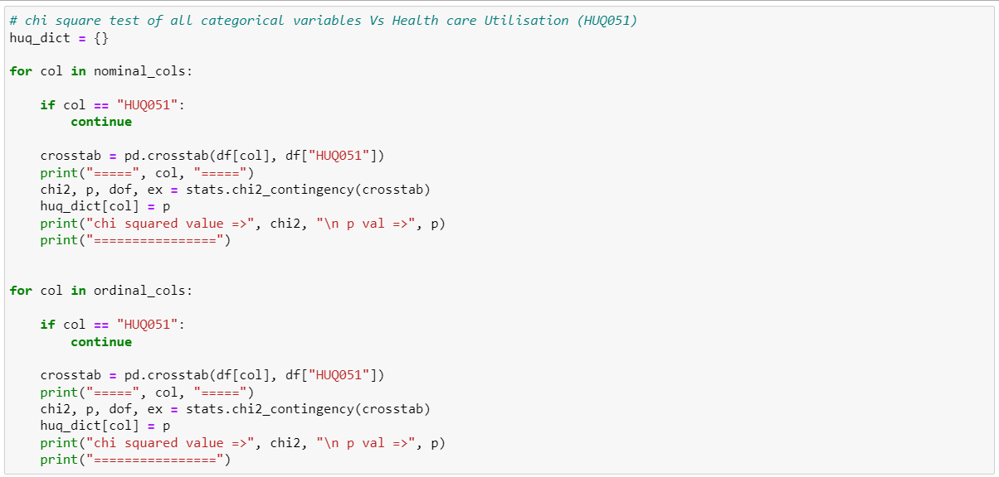

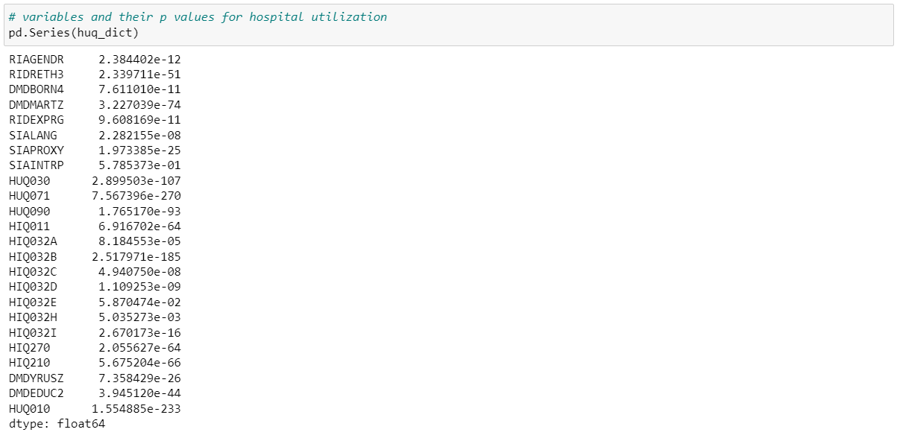

Chi Square Test between Health Insurance Coverage (HIQ011) and other target variables,

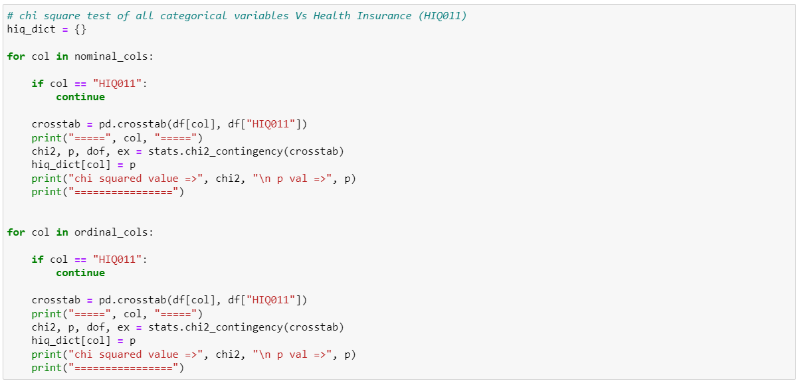

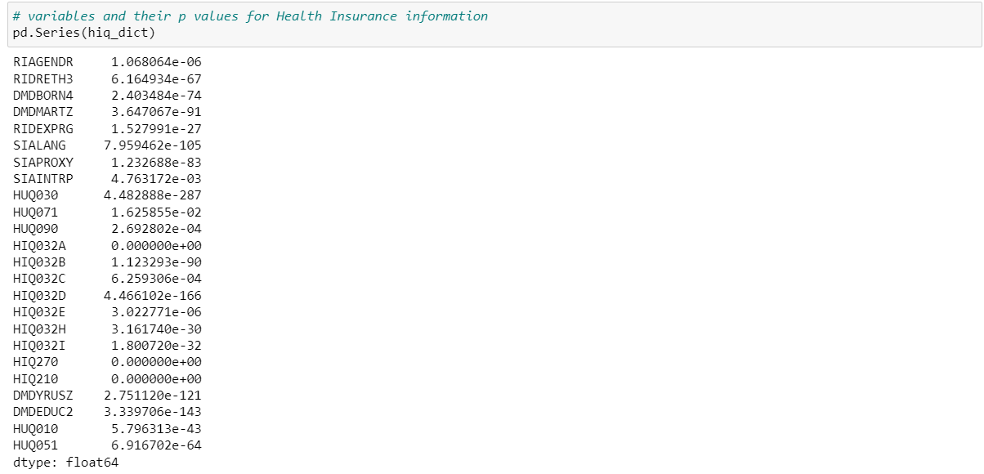

We see all the variables to have a significant association with the target variables HUQ051 (Hospital Utilization), HIQ011 (Health Insurance Coverage)

### Kruskal Wallis Test

We utilized Kruskal Wallis test to identify if there is a significant difference between the at least one of the groups of hospital utilization levels (HUQ051) based upon their family income to poverty ratio (INDFMPIR)



We see there is a significant difference between at least one of the two groups of hospital utilization levels.

### Post Hoc Dunn Test

To understand which groups, have a significant difference from the Kruskal Wallis test performed above, we use post hoc analyses i.e., Dunn test.

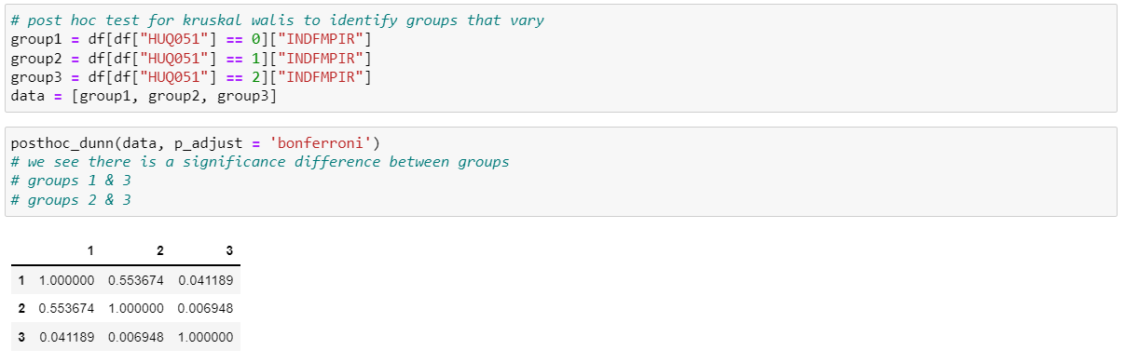

We see the following to differ significantly from each other.

* Group 1 (Low Utilization) and Group 3 (High Utilization)
* Group 2 (Moderate Utilization) and Group 3 (High Utilization)

### Mann Whitney U Test

We see Mann Whitney U test to find if there is a significant difference between the Health Insurance coverage groups (Yes, No) when compared based on the family income to poverty ratio (INDFMPIR)

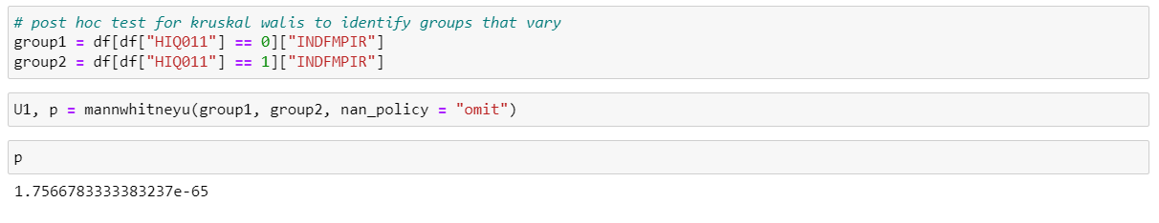

We observe based on the p value of the test there is a significant difference of family income to poverty ratio (INDFMPIR) when compared across people with insurance coverage and people who are not covered by insurance.

* 1. Data Visualization:

Python was used for visualization. Bar graphs, stacked bars, sunburst charts, heat maps, and other types of representations were created using Matplotlib, Plotly, seaborn, and pandas. With the aid of Plotly and Seaborn, We were able to produce intricate and incredibly rich graphics. Our ability to illustrate hierarchical distribution via a sunburst chart was made possible by Plotly. We were able to create a heat map chart to show the correlation between variables using the seaborn package.

6.5.1 The diagram of a sunburst is shown below. These were created utilizing the data variables from the dataset.

The chart displays a hierarchical view of the variables. It illustrates how different racial groups—including non-Hispanic White, non-Hispanic Black, Mexican American, non-Hispanic Asian, other Hispanic, and other race—utilized hospitals at low, moderate, or high rates based on their age, income, and whether they have insurance or not.

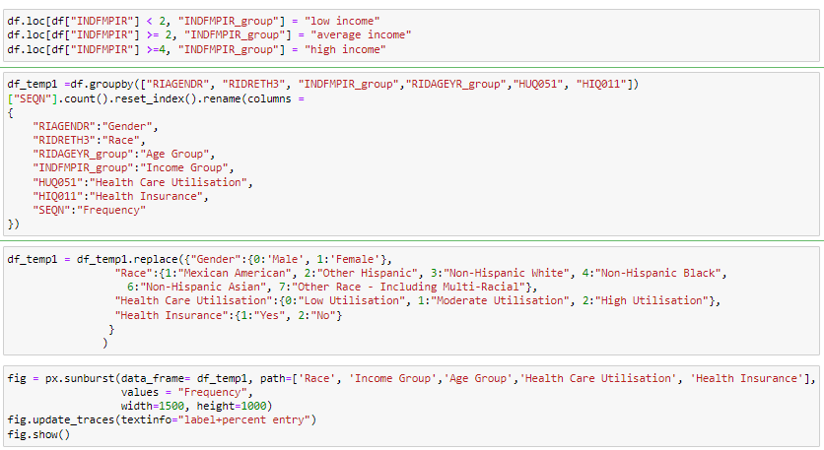

Figure: The code above is used to create a sunburst chart to represent hierarchical relationship between variables.

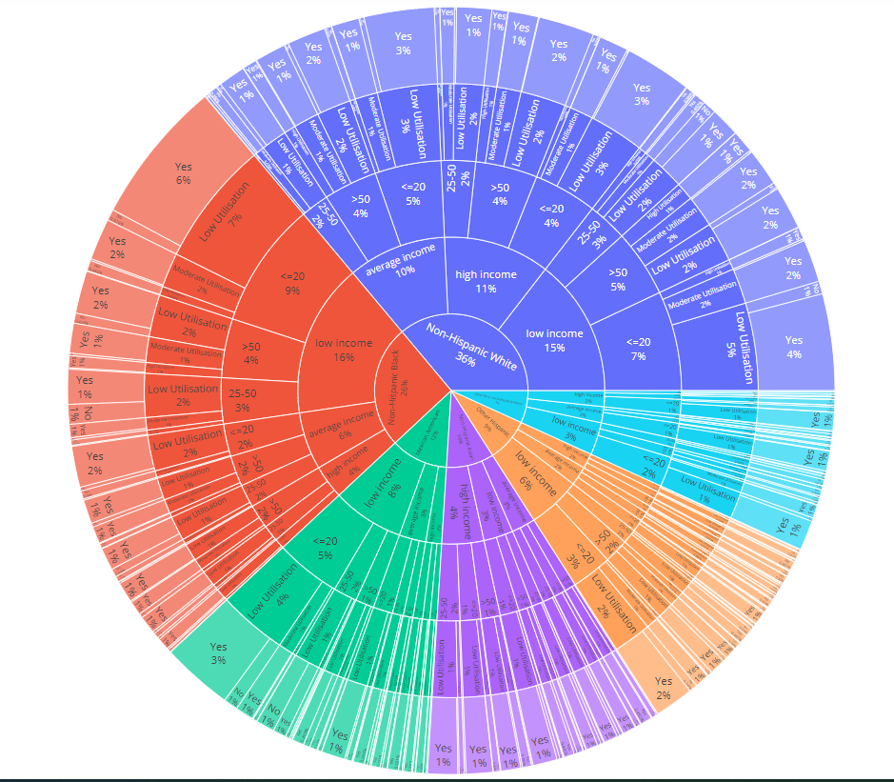

Figure: Sunburst Chart representation to show hierarchial representation of variables. Through the above chart we can check how different races according to their age and income are utilizing healthcare and if they are covered by insurance or not. Through the graph we can infer that majority of respondents are Non-Hispanic Whites followed by Non-Hispanic Blacks.

* 1. Dependent Variables Detailed View
* Health Insurance Coverage

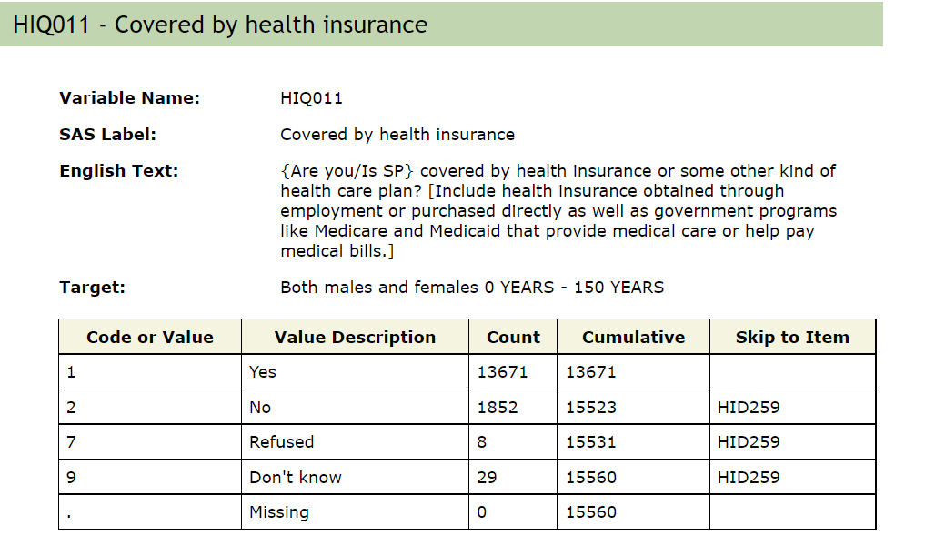

* Hospital Utilization

For the sake of simplicity we further group the below classes into three groups – Low, Moderate & High

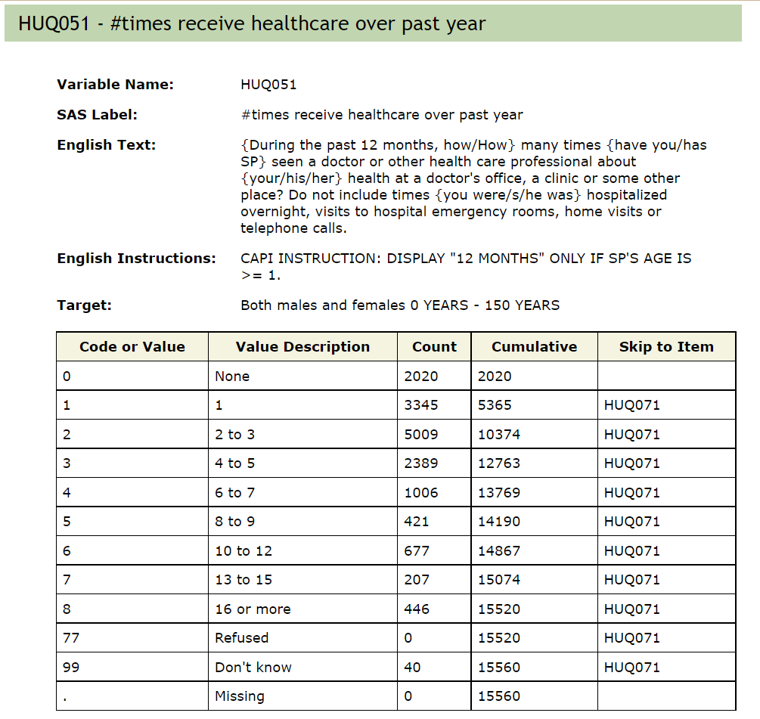

New Class Range,

|  |  |
| --- | --- |
| **Hospital Utilization HUQ051** | |
| Old Class | New Class |
| 0,1,2 | Low |
| 3,4,5 | Moderate |
| 6,7,8 | High |

1. Clustering

We perform multiple clustering methods to identify best method which outputs clusters which can be logically labeled and also proves to have a high silhouette score

* 1. K prototype Clustering

It is a method of clustering which we are using to process Categorial data and numerical data.

### Elbow Plot

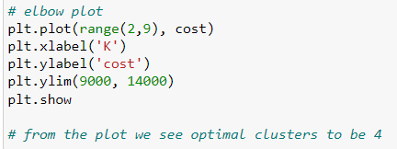

Figure: The code above is used to plot the elbow for K- prototype clustering

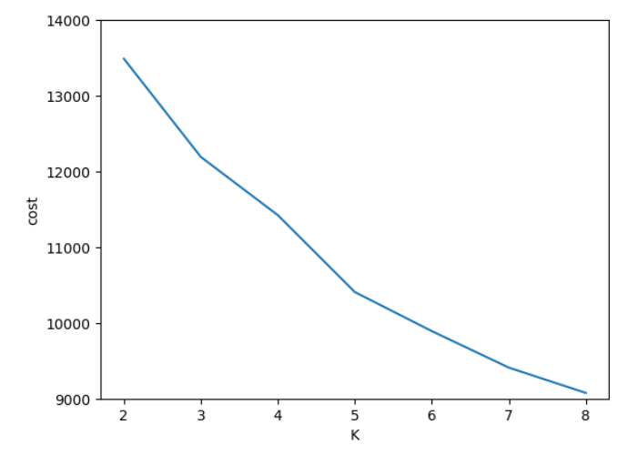

Figure: From the elbow plot plotted we infer that there are 3 clusters.

### Cluster Visualization

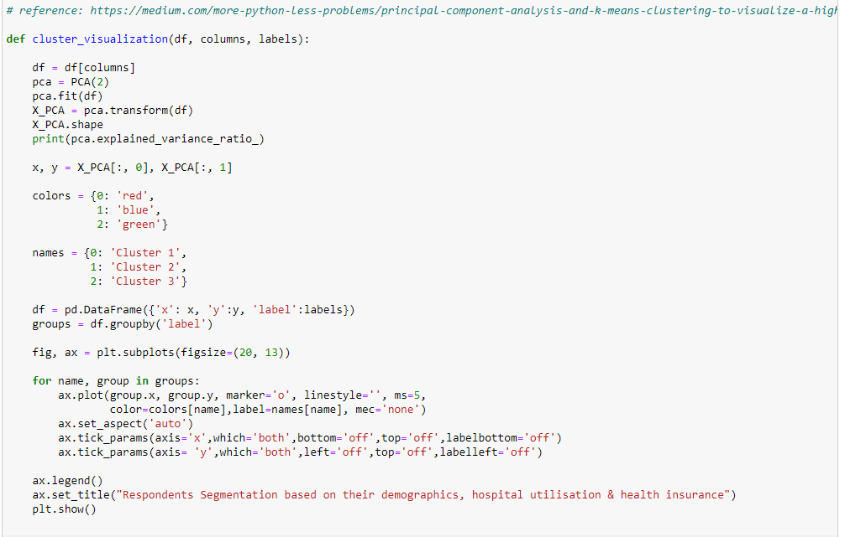



Figure: The above codes are used to visualize the 3 clusters formed. We are using principal component analysis to convert the data to 2 dimensional so that we can visualize the clusters..

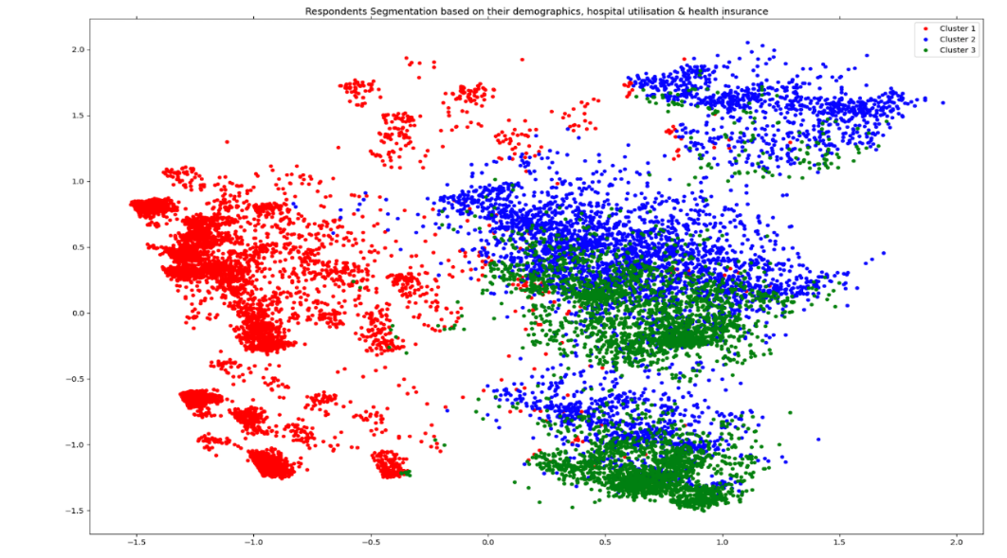

Figure: Representation of clusters.

### Cluster Labels

- CLUSTER 0 - Between the ages of 20 and 80, Americans of low socioeconomic status who speak English visited hospitals more frequently for medical reasons than persons who were in good condition.

- CLUSTER 1 – Participants in the study came from a variety of ethnic backgrounds, but Non-Hispanic Whites and Non-Hispanic Blacks had the highest participation rates and were more likely to have their prescriptions reimbursed by insurance because of their high socioeconomic class.

CLUSTER 2 – People from all socioeconomic backgrounds who are single and most young adults with graduate degrees are in excellent physical and mental health have their health insurance plans covered and have not seen a mental health expert.

### Silhouette Score

The silhouette value gauges an object's cohesion with its own cluster in comparison to other clusters.

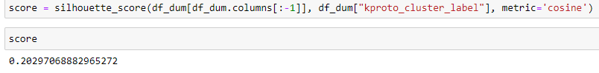

Figure: Representation of silhouette score. 0.29 is the silhouette score through which we can interpret that the clusters are fairly dense and separated.

* 1. Agglomerative Clustering:

Clustering Technique :

It is a type of hierarchical clustering. We have used cosine distance as a distance metric.

### Cluster Visualization:

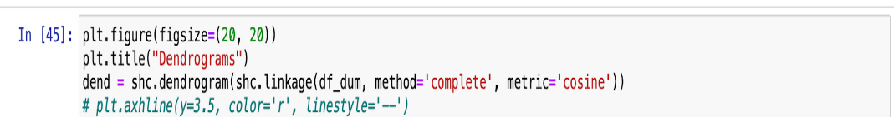

Figure: The given code is used to plot the dendogram to visualize agglomerative clustering.

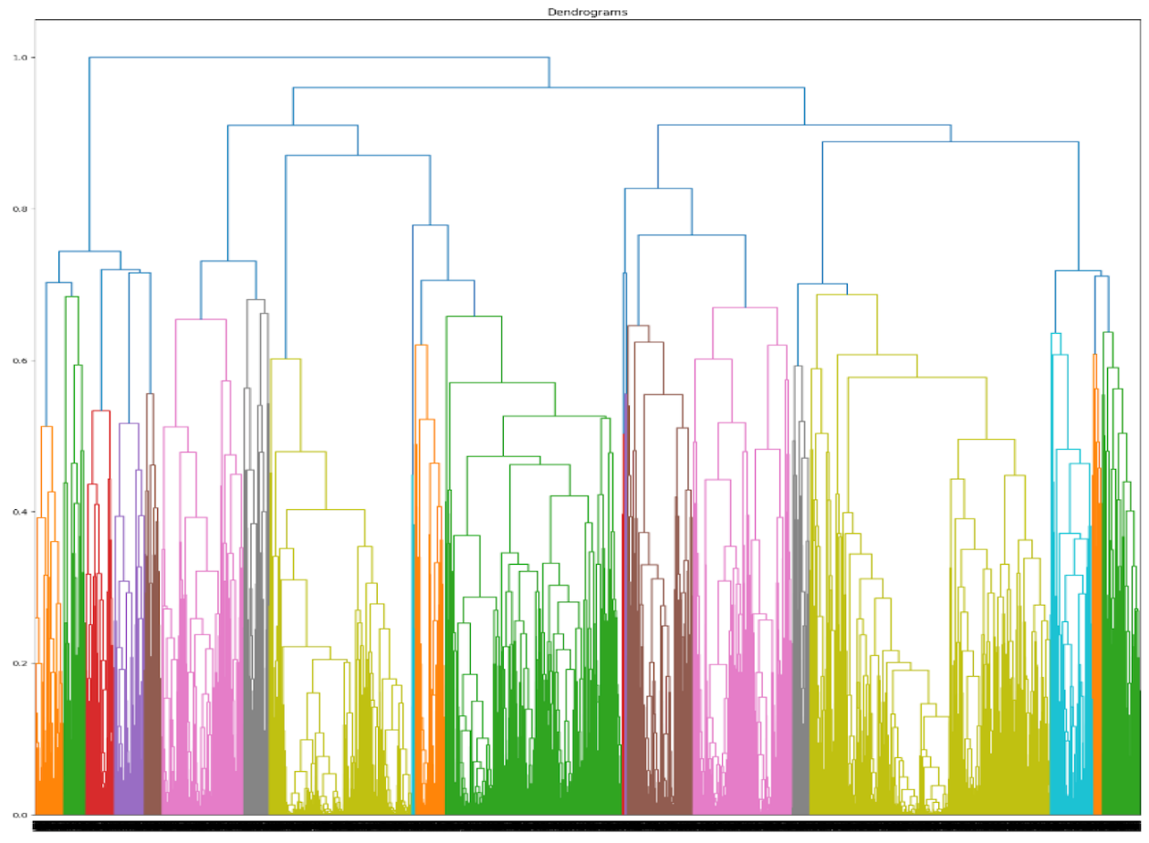

Figure: Representation of dendogram to visualize 5 clusters through aglomerative clustering

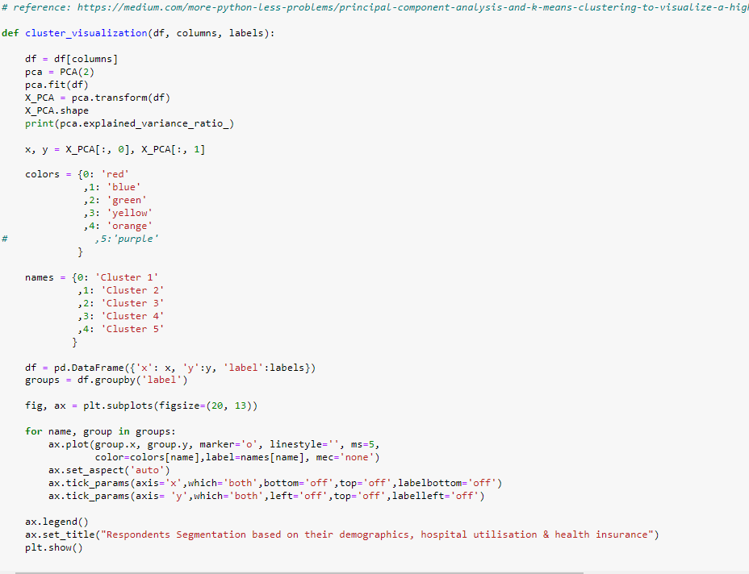

Figure: The above codes are used to visualize the 5 clusters formed. We are using principal component analysis to convert the data to 2 dimensional so that we can visualize the clusters.

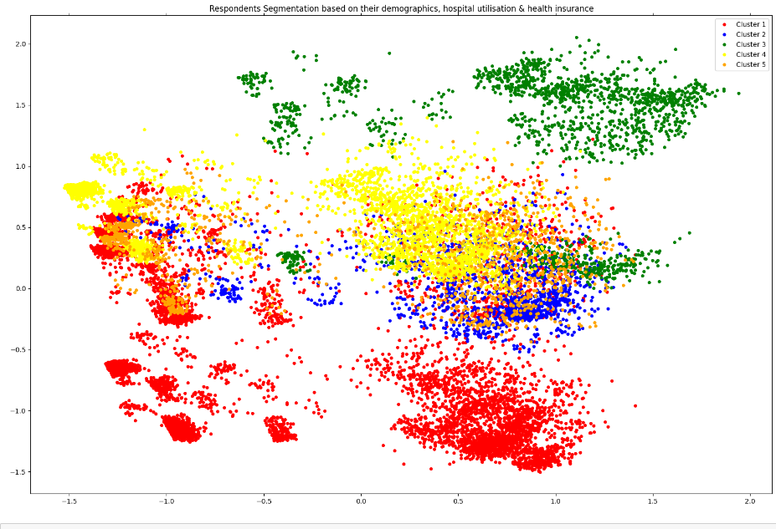

Figure: Representation of 5 clusters through agglomerative clustering

### 1.1Cluster Labels

- CLUSTER 0: People from the US who speak English and are Non-Hispanic Blacks have no proxies and interpreters during the study are insured by health insurance and in good health.

- CLUSTER 1: Both males and females who are English speaking, are college graduates have access to healthcare, are in good health, and have health insurance.

- CLUSTER 2: Non-Hispanic Whites of high socioeconomic backgrounds who are graduates in the US are in excellent health, have insurance coverage, and are involved in a variety of marital situations yet fail to disclose their pregnant status at the exam.

-CLUSTER 3: None of the races in this cluster had health insurance, nor visited a hospital, nor sought out a mental health professional.

-CLUSTER 4: In this cluster younger Mexican Americans living in the US are in good health and have health insurance.

### Silhouette Score

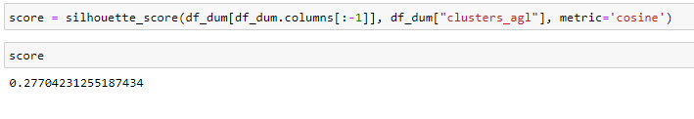

Figure: Representation of silhouette score. 0.27 is the silhouette score through which we can interpret that the clusters are fair and separated.

1.3 Affinity and Agglomerative Clustering

### 1.3.1 Clustering Technique: We are using a combination of affinity and agglomerative clustering since affinity clustering outputs more than 500 clusters we are using agglomerative clustering on top of the cluster centroids to reduce the number of clusters to 3

### 1.3.2 Cluster Visualization

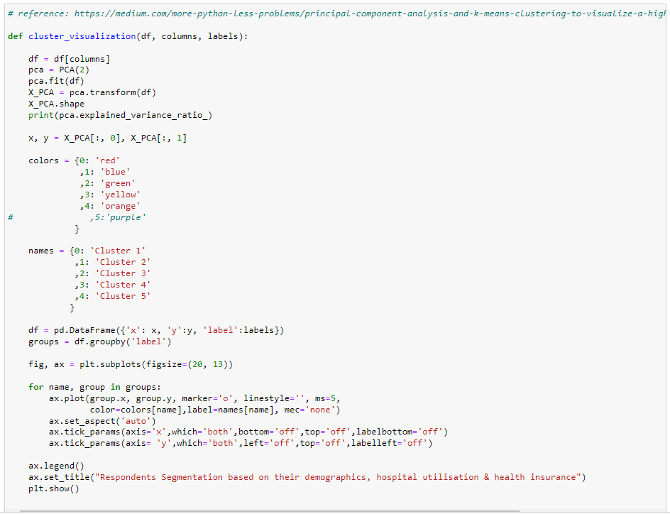

Figure: The above codes are used to visualize the 3 clusters formed. We are using principal component analysis to convert the data to 2 dimensional so that we can visualize the clusters. We have used affinity clustering along with agglomerative clustering.

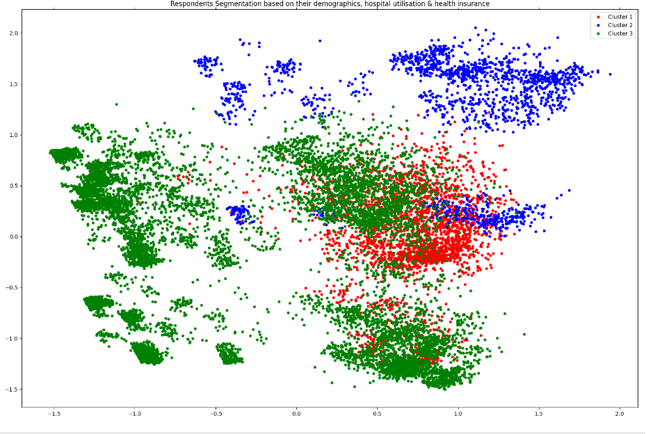

Figure: Representation of 3 clusters through affinity and agglomerative clustering

### 1.1.2 Silhouette Score

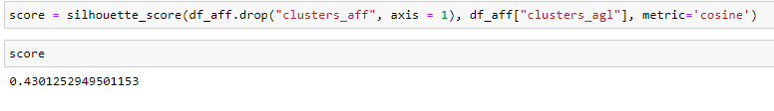

Figure: Representation of silhouette score. 0.43 is the silhouette score through which we can interpret that the clusters are well dense and separated.

1. Predictive Modeling

In our project we have two target variables which we are trying to predict and evaluate,

* Hospital Utilization (HUQ051)
* Health Insurance Coverage (HIQ011)
  1. Methodology

We followed a common methodology to predict each of the target variables. We perform the following in sequence

* One-Hot Encoding

Convert categorical variables to a form that can be utilized by the machine learning algorithm



* Train Test Split

Split the complete data into training data and testing data. We use training data to train the model and test data to evaluate the model



* SMOTE

SMOTE stands for Synthetic Minority Oversampling Technique. Since our target variables is imbalanced SMOTE technique allows us to oversample the minority class and under sample the majority class. We use the imblearn package.



* Grid Search-Hyper parameter tuning

To find the best hyperparameters for each of the model use Grid Search. This enables us to run multiple combinations of hyperparameters efficiently. We also perform cross validation during the Grid Search



* Confusion matrix, Precision, recall, F-1 score, ROC-AUC curve

To evaluate the machine learning model output we check the respective model metrics such as precision, recall, f-1 score

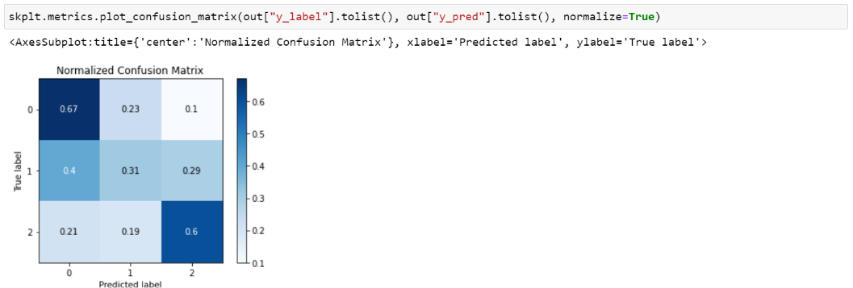

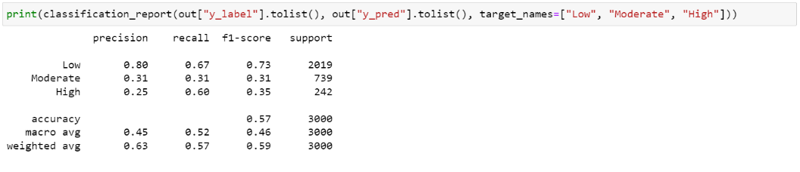

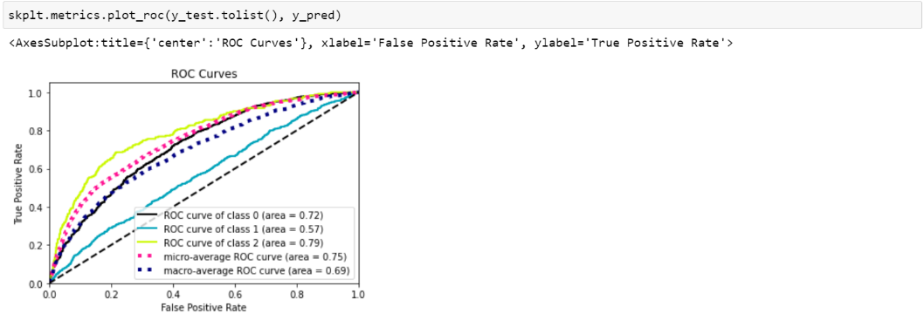

* Threshold optimization (Only for Health Insurance Coverage (HIQ011))

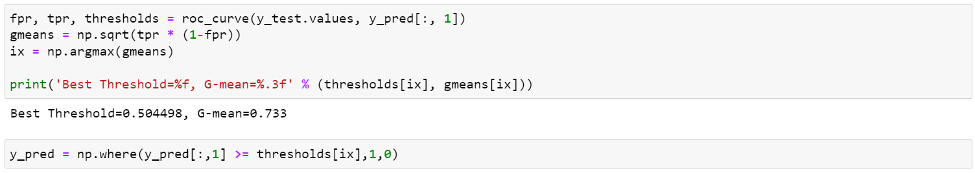

For Health Insurance Coverage it is a binary classification problem (Yes/No). We use a method called G-Means to identify the best threshold probability to classify the binary classes

* 1. Predicting Hospital Utilization Frequency
     1. Logistic Regression Model Classification

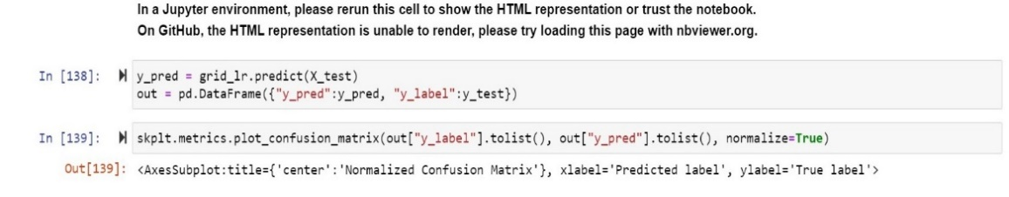

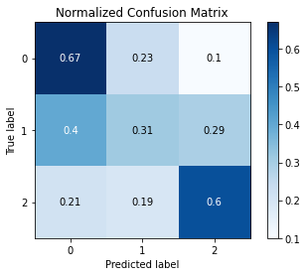

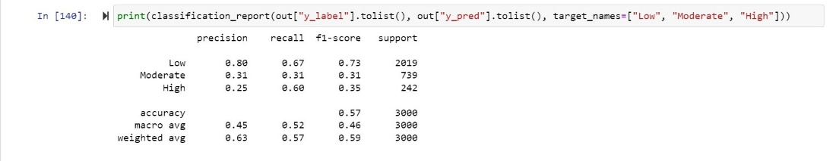

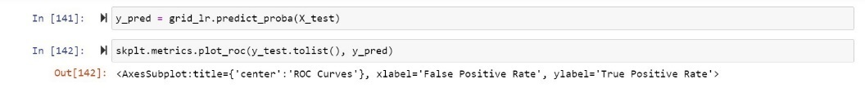

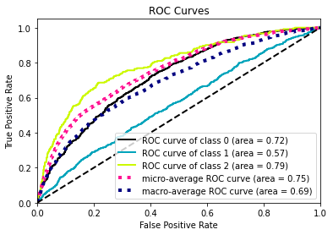

### 8.2.2 Random Forest Classifier

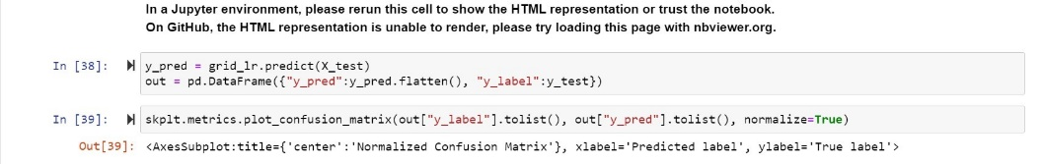

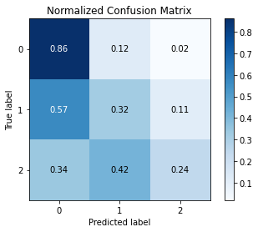

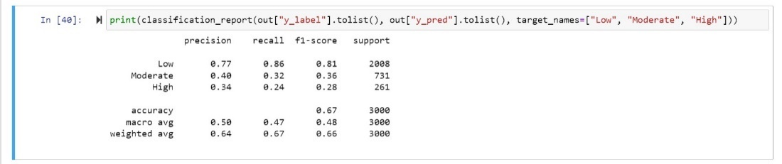

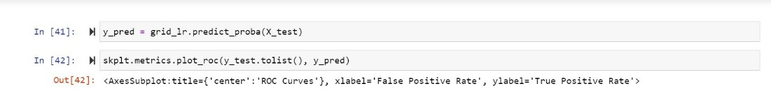

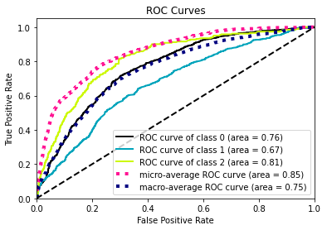

### XGBoost Classifier

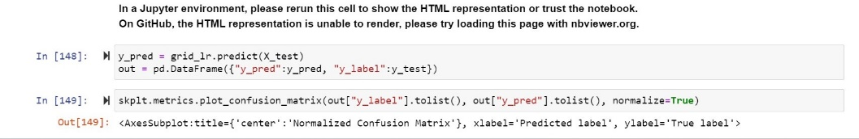

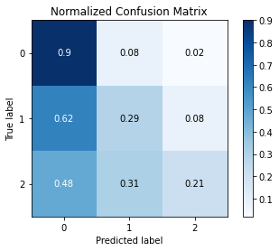

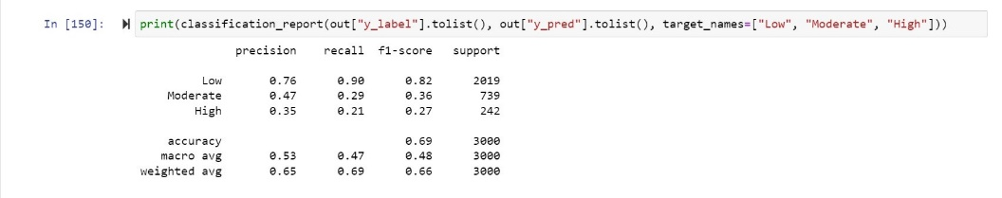

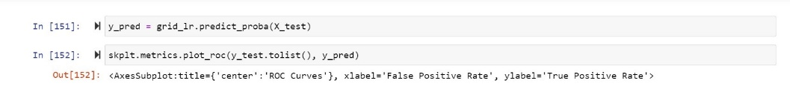

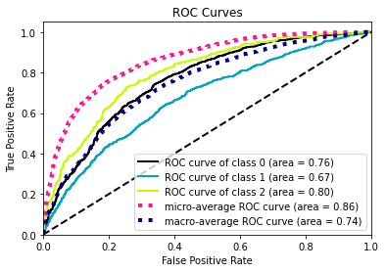

### 8.2.4 LightGBM Classifier

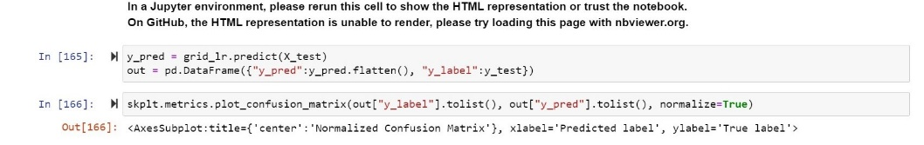

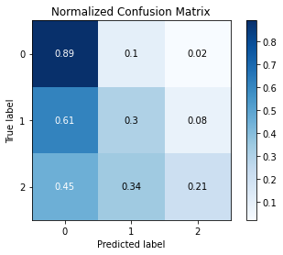

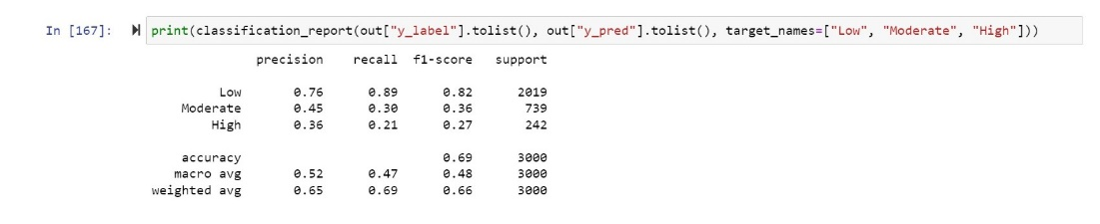

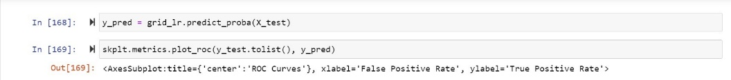

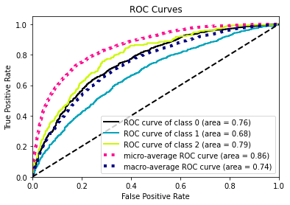

### 8.2.5 MLP Classifier

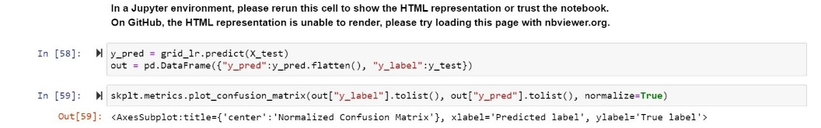

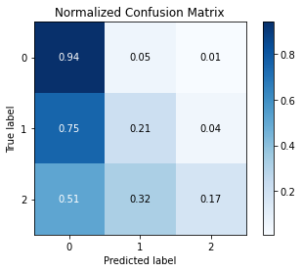

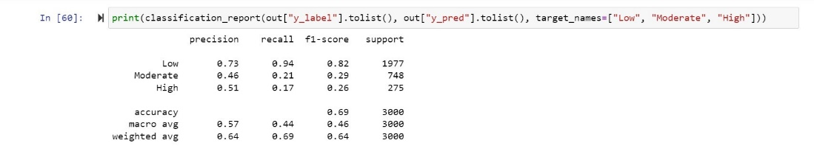

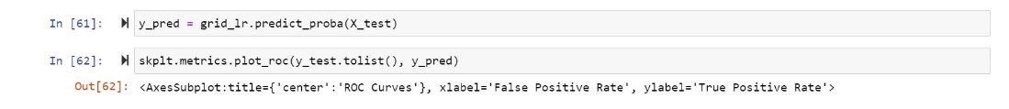

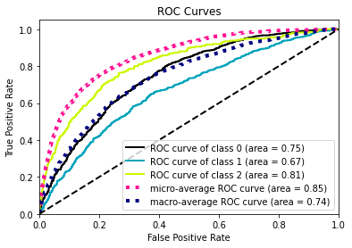

### 8.2.6 Catboost Classifier

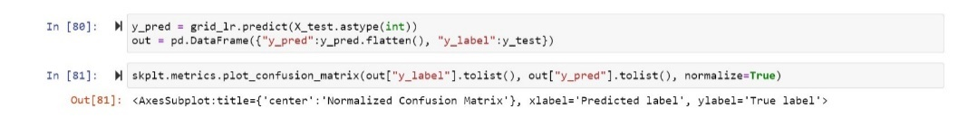

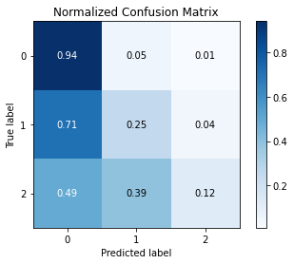

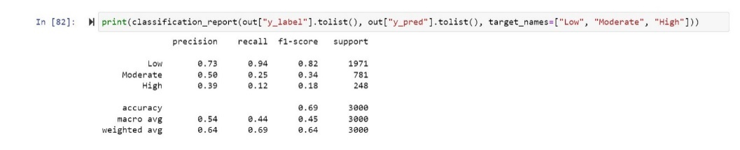

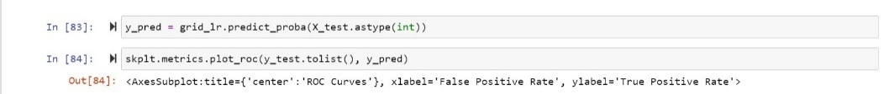

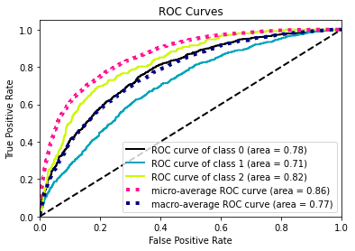

* 1. Predicting Health Insurance Coverage
     1. Logistic Regression Model Classifier

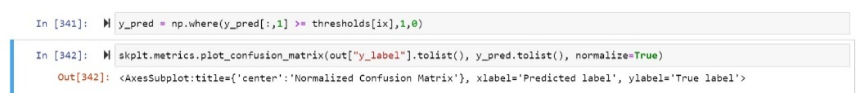

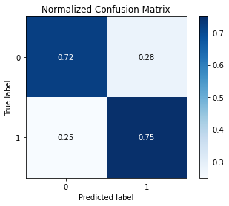

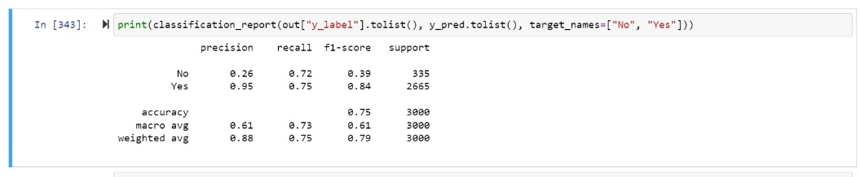

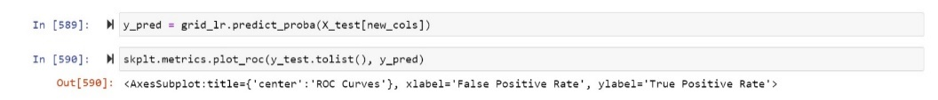

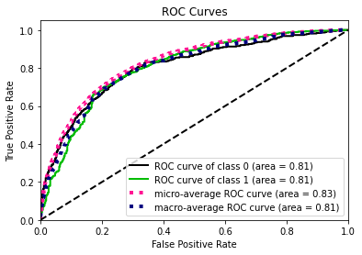

### Random Forest Classifier

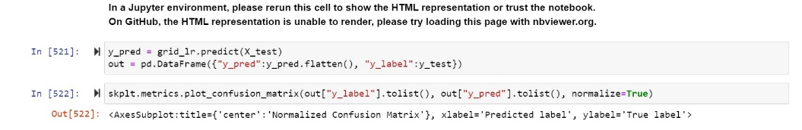

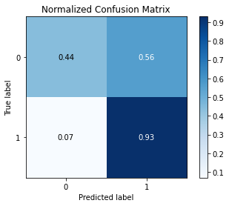

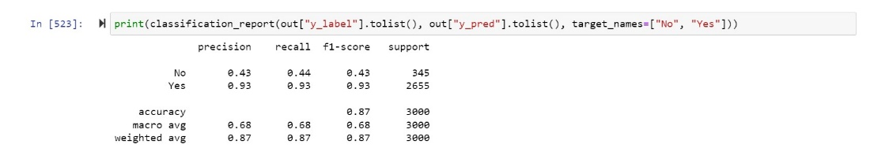



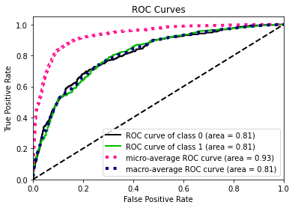

### XGBoost Classifier

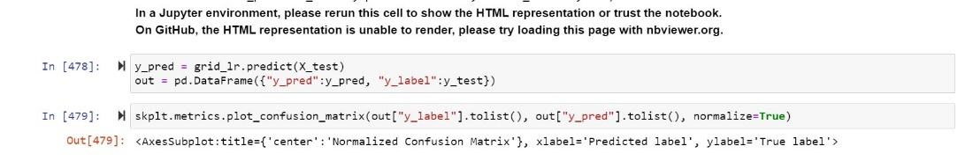

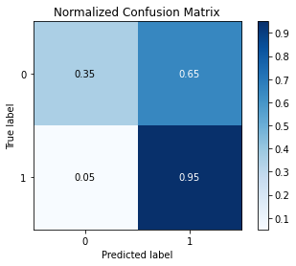

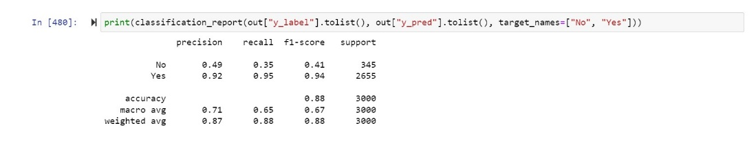

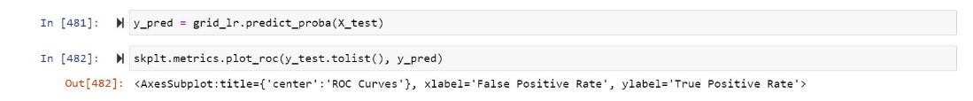

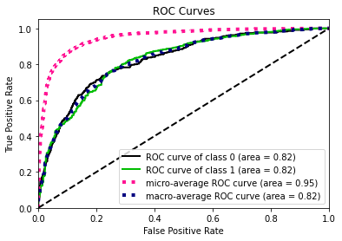

### LightGBM Classifier

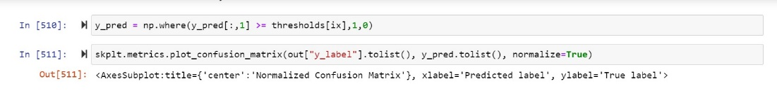

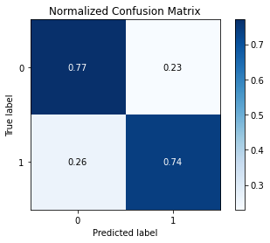

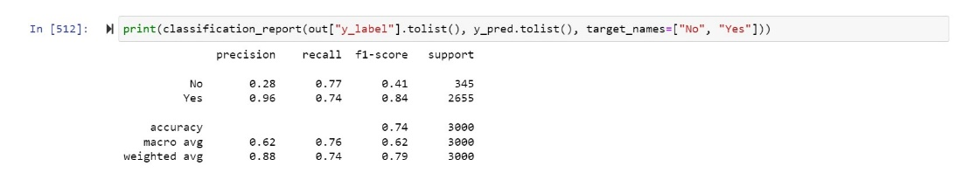

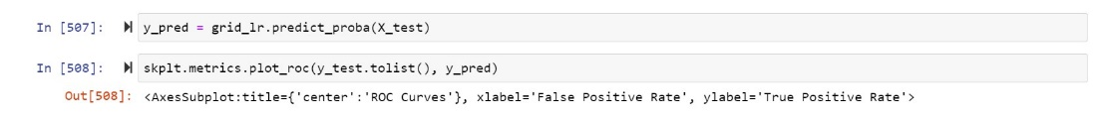

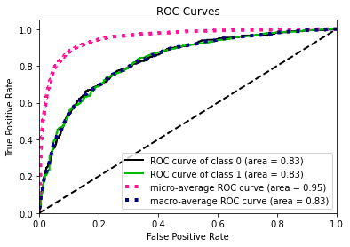

### MLP Classifier

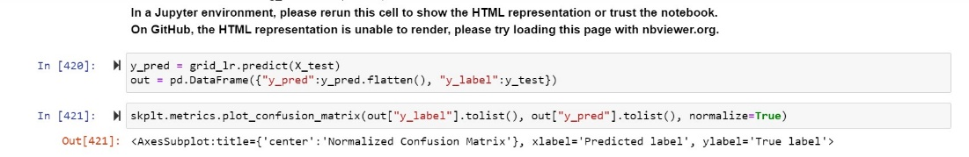

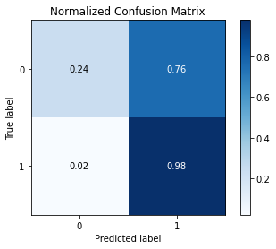

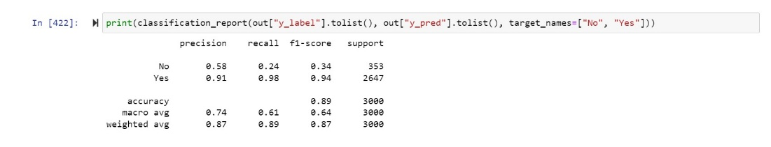

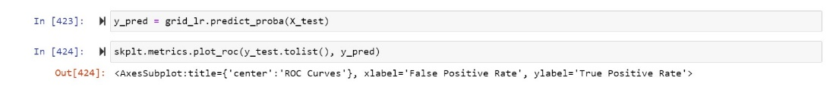

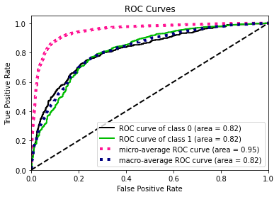

### Catboost Classifier

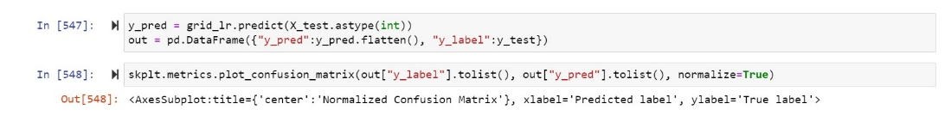

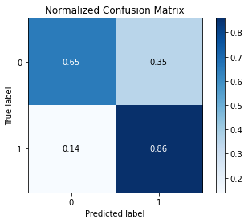

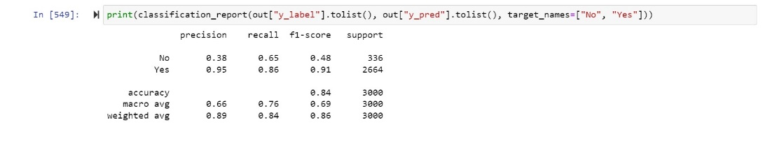

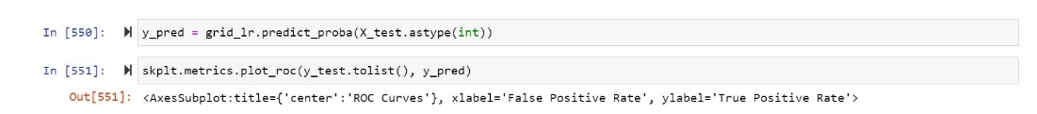

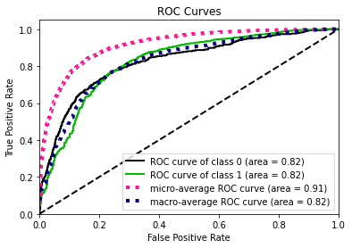

* 1. Feature Importance Inference

### Hospital Utilization:

We observe that age, income ratios, ethnicity/race, and education are major factors in feature importance.

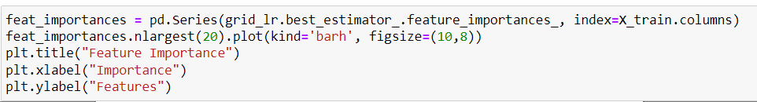

Figure: The code above is used to show which variable has more importance in the model.

#### XG-BOOST

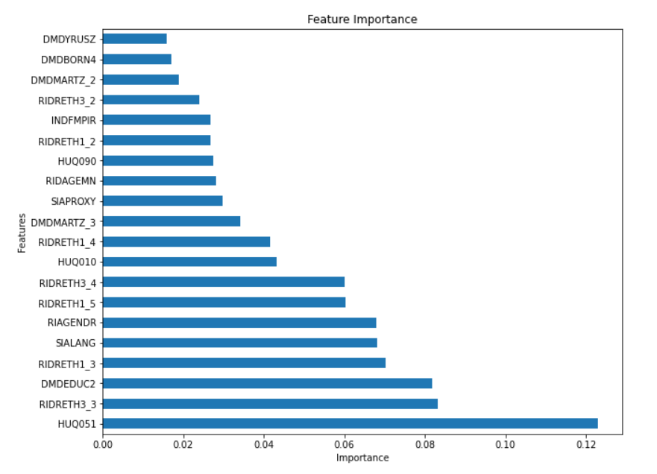

Figure: HUQ051 has more importance in XG-Boost.

#### LIGHT GBM

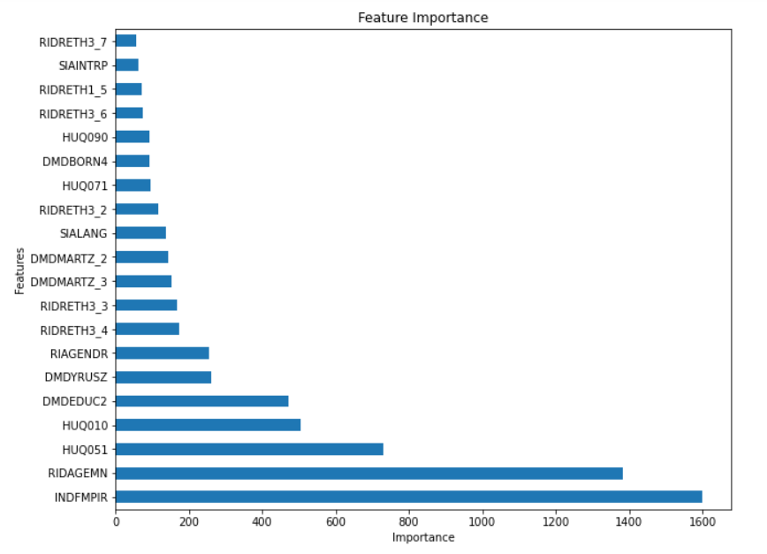

Figure: INDFM

#### Random Forest Classifier

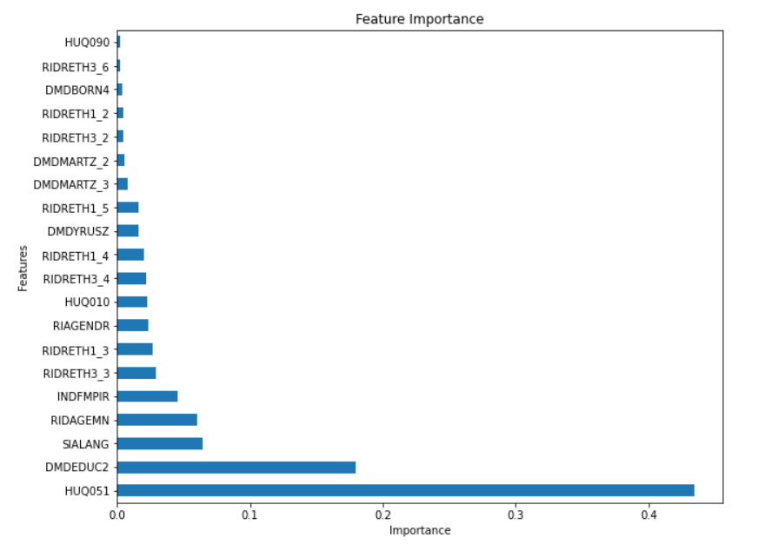

#### CATBOOST

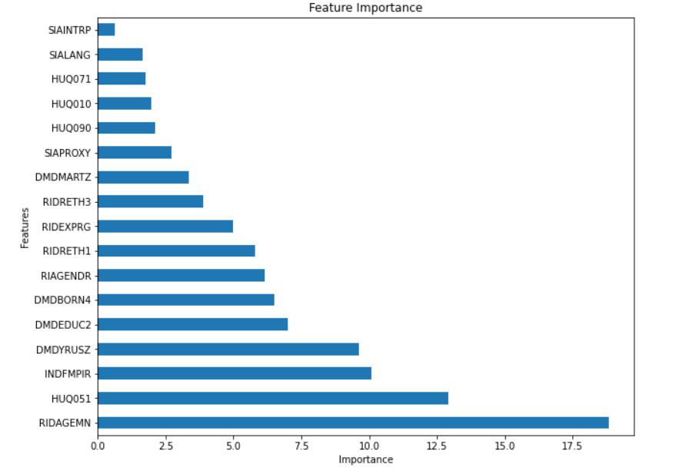

### Health Insurance Feature Importance Inference

#### 

#### XGBoost Classifier

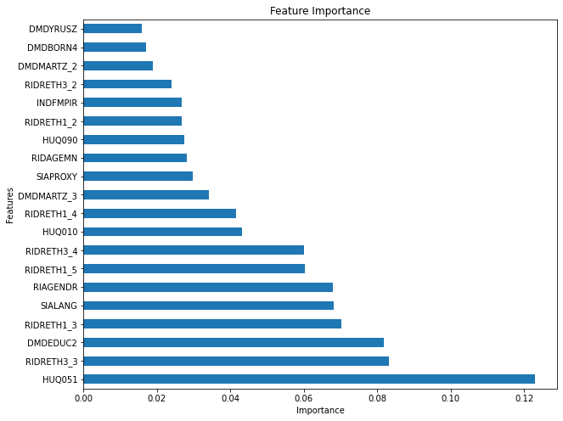

#### LIGHT GBM

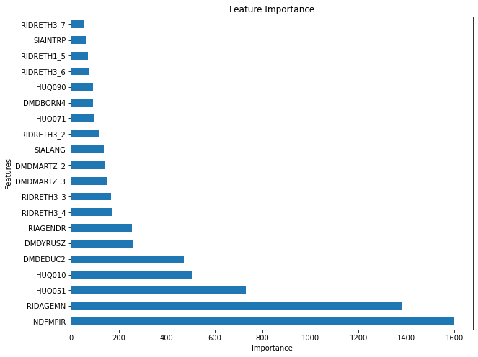

#### Random Forest Classifier

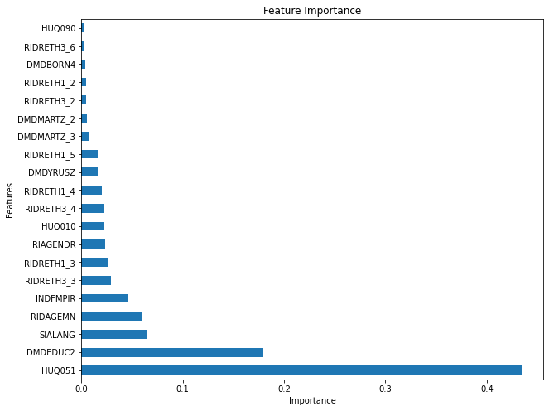

#### CATBOOST

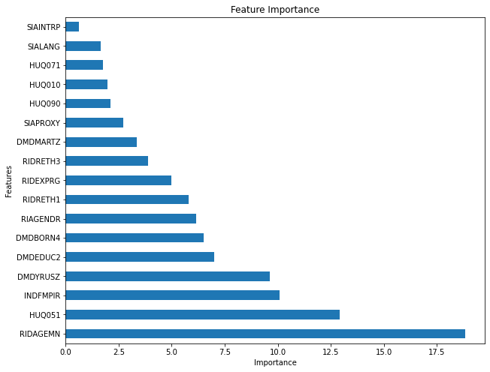

* 1. Model Evaluation Results Inference

From the above modeling results we infer the following,

### Evaluation Metrics

#### Health Insurance Coverage Evaluation Metrics

For our case we see it makes sense to predict all respondents with no health insurance coverage. Hence we look at the recall score for the class which represents respondents who are not covered by health insurance.

We see Catboost Classifier and MLP Classifier perform best out of all algorithms used with a recall score of ~0.77 (77%). This represents we are able to predict 77% of all respondents who do not have health insurance accurately as not covered.

#### Hospital Utilization Evaluation Metrics

From our data analysis we observed that most people who are not covered by health insurance fall within the low hospital utilization category. Hence it is important to classify them correctly when predicting hospital utilization.

Similar to our evaluation of Health Insurance coverage, see Catboost Classifier and MLP Classifier perform best out of all algorithms used with a recall score of ~0.94 (94%). This represents we are able to predict 94% of all respondents who will fall under low healthcare utilization

### Feature Importance Inference

Based on the feature importance of the tree algorithms we see the following,

#### Health Insurance Predictive Model Feature Importance Inference

We see the following attributes to commonly have an impact on predicting the health insurance coverage of a respondent

* RIDRETH3 – Race and Ethnicity
* DMDEDUC1 – Education level
* HUQ051 – Hospital Utilization Level
* SIALANG – Language of Interview
* INDFMPR – Family Income to Poverty Ratio
* RIDAGEMN - Age in Months

#### Hospital Utilization Predictive Model Feature Importance Inference

We see the following attributes to commonly have an impact on predicting the hospital utilization levels of a respondent

* RIDRETH3 – Race and Ethnicity
* HIQ032B - Covered by Medicare
* HUQ071 - Overnight hospital patient in last year
* INFMPR – Family Income to Poverty Ratio
* RIDAGEMN – Age in Months
* HUQ010 - General health condition

1. Summary of Findings
   1. Research Question One Findings

* We observe the alternate hypothesis to be significant and there are significant associations between health insurance status and hospital utilization of respondents when compared across demographics for the survey respondents.
  1. Research Question Two Findings
* We observe to have meaningful groups of clusters across the data that can be identified, and they do vary. We see we can label the clusters to logical groups. For affinity and agglomerative clustering combination we see the Silhouette score to be good.
  1. Research Question Three Findings
* We observe to have significant insights from the combined demographics, hospital utilization and health insurance data from our exploratory data analysis. We see we can identify factors that play a major role in affecting health care utilization and health insurance status of respondents

1. Limitations

We were limited by our skillsets to perform advanced data analysis on our data and use more complicated model like advanced neural networks. We would have liked to trial more methods on the imbalanced classification problem

References

1. Sommers, Benjamin D. MD, PhD. Why Health Insurance Matters—and Why Research Evidence Should Too. Academic Medicine: September 2017 - Volume 92 - Issue 9 - p 1228-1230 doi: 10.1097/ACM.0000000000001723
2. Ryan J. Rosso U.S. Health Care Coverage and Spending
3. Moore, L., Cisse, B., Batomen Kuimi, B. L., Stelfox, H. T., Turgeon, A. F., Lauzier, F., Clément, J., & Bourgeois, G. (2015). Impact of socio-economic status on hospital length of stay following injury: a multicenter cohort study. *BMC health services research*, *15*, 285. https://doi.org/10.1186/s12913-015-0949-2
4. Gresenz, C. R., Rogowski, J., & Escarce, J. J. (2009). Community demographics and access to health care among U.S. Hispanics. *Health services research*, *44*(5 Pt 1), 1542–1562. https://doi.org/10.1111/j.1475-6773.2009.00997.x

# Appendix

**# Converting the files from xpt to csv:**

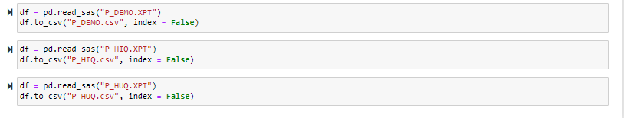

**# Data loading:**

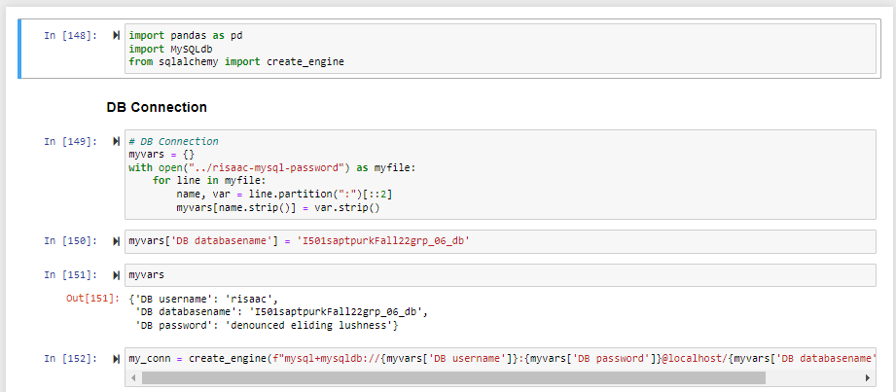

**# P_DEMO loading:**

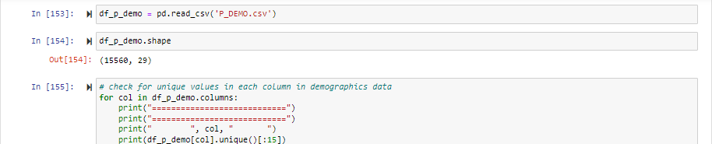

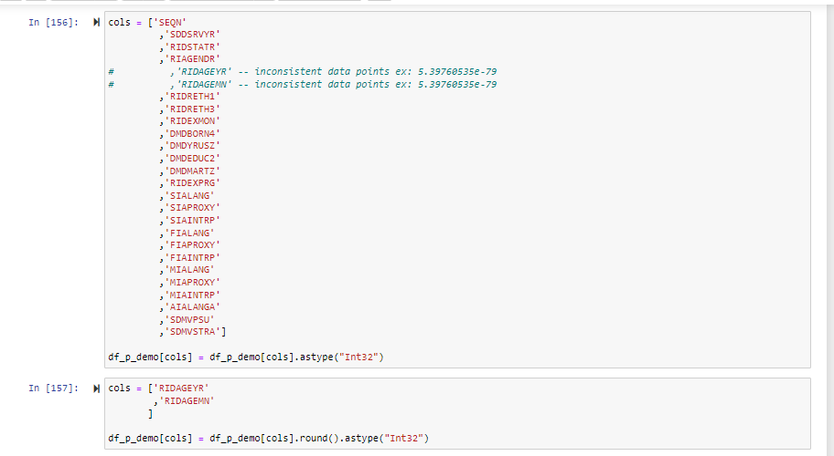

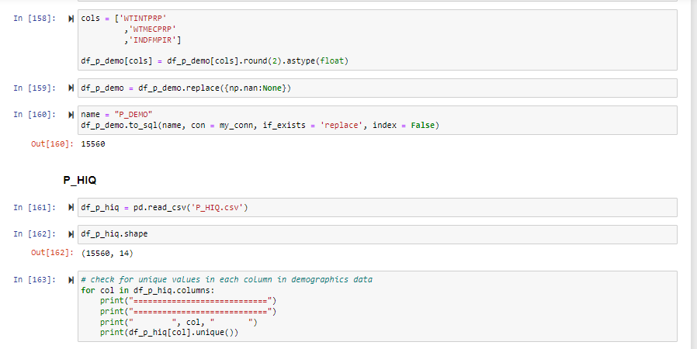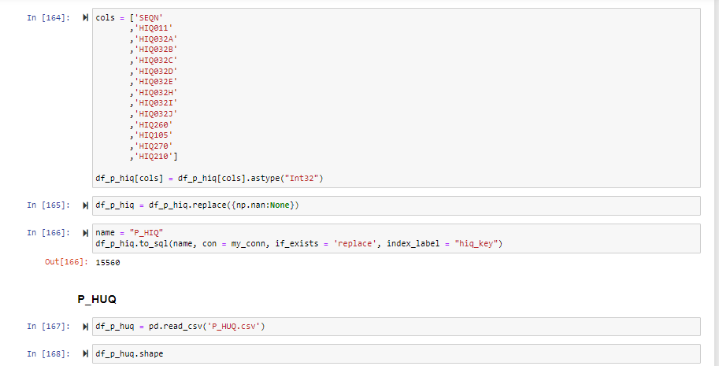

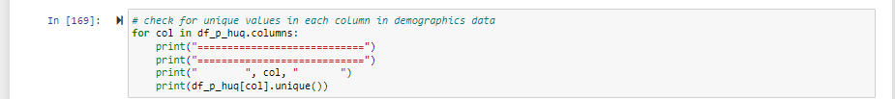

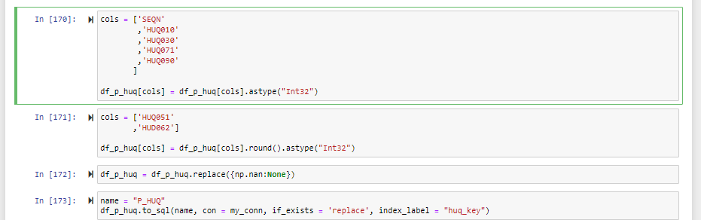

**# Creating primary and the foreign key for the datasets:**

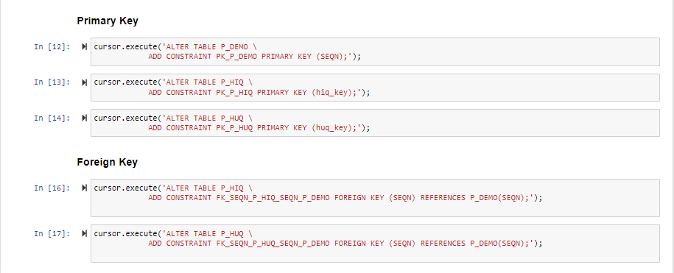

**# Data cleaning:**

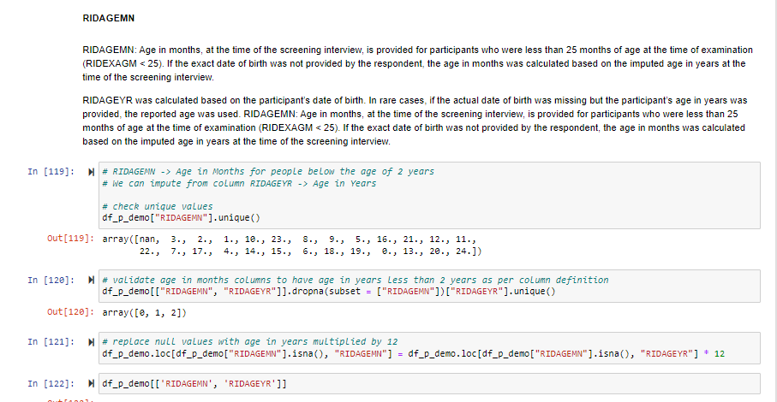

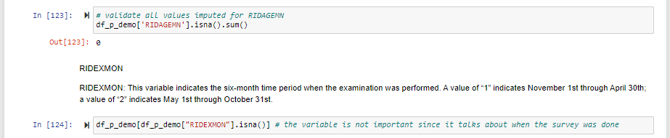

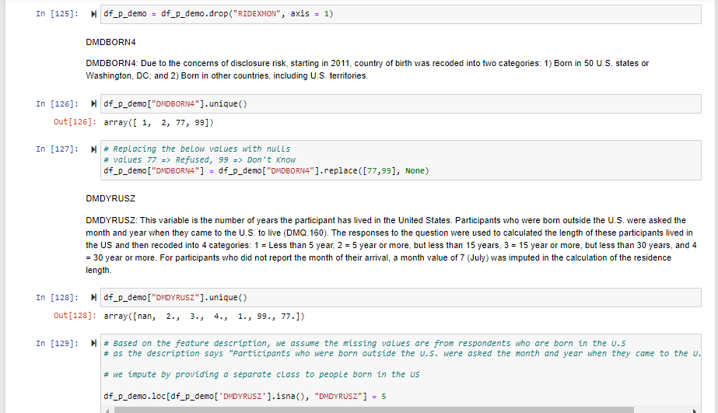

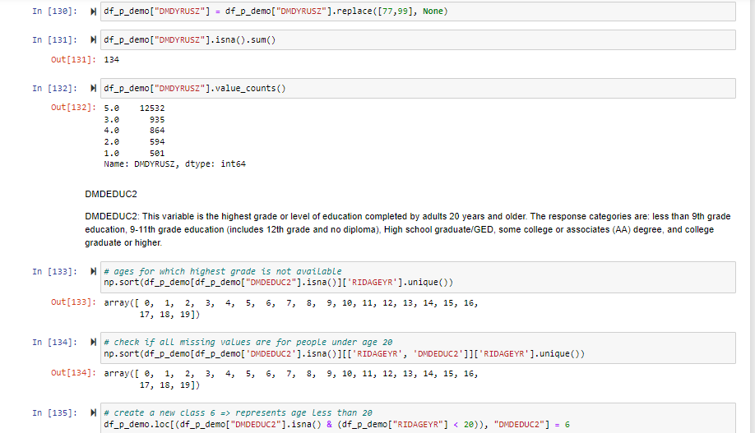

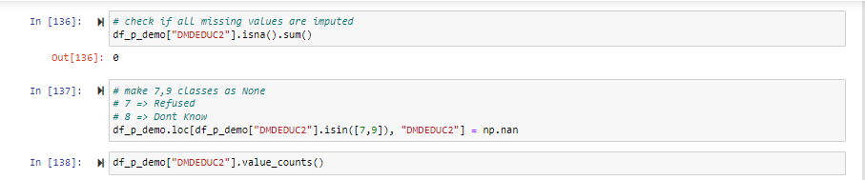

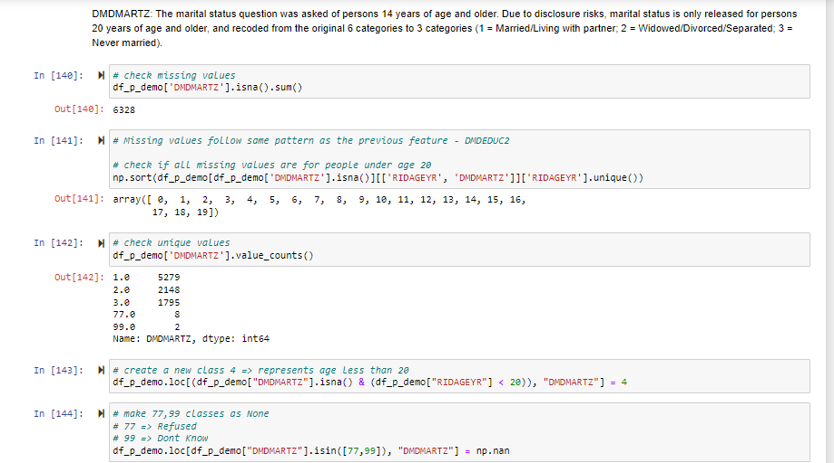

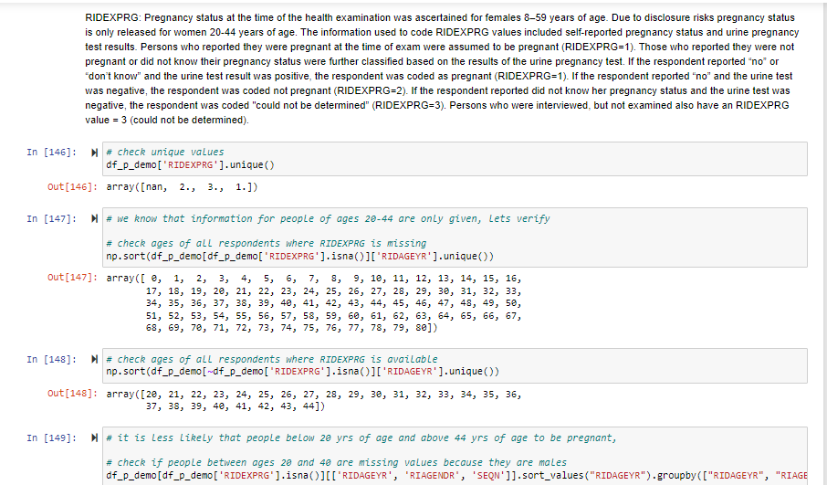



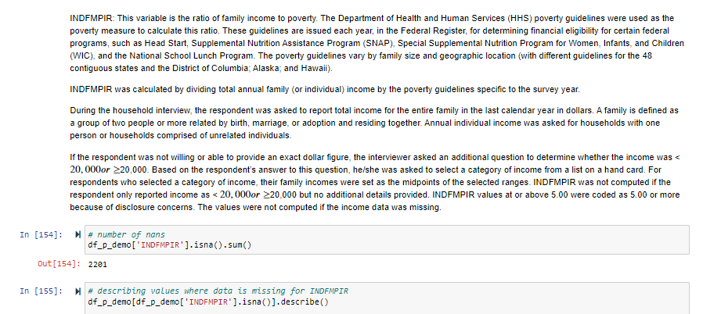

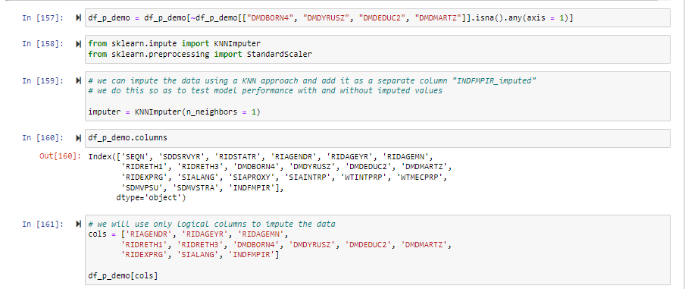

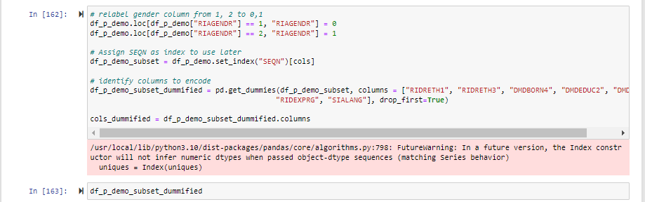

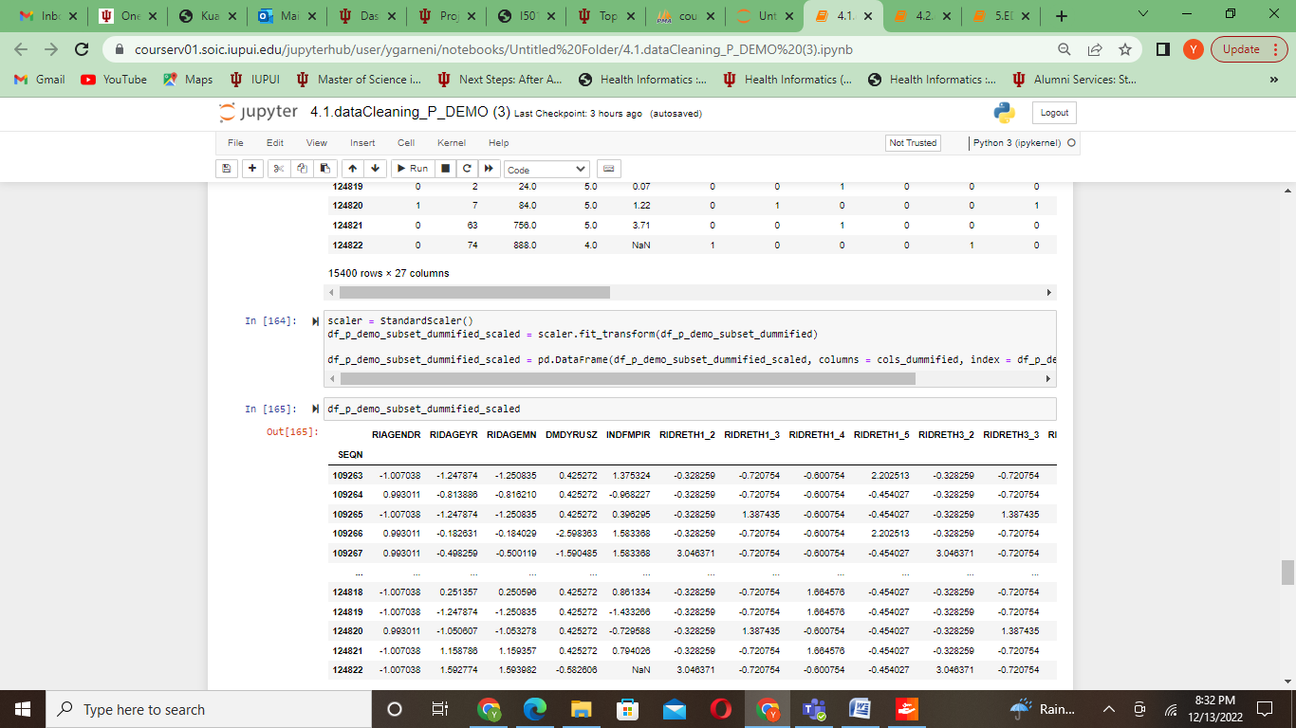

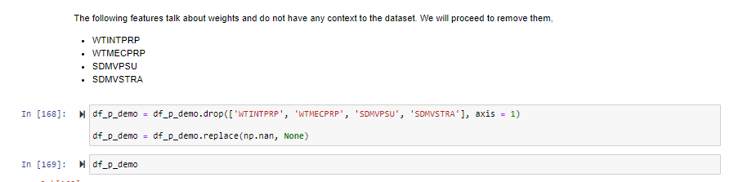

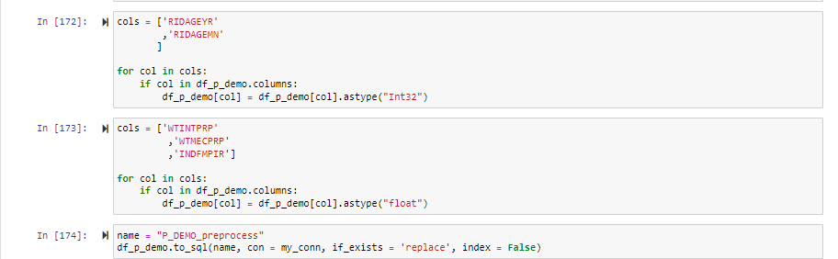

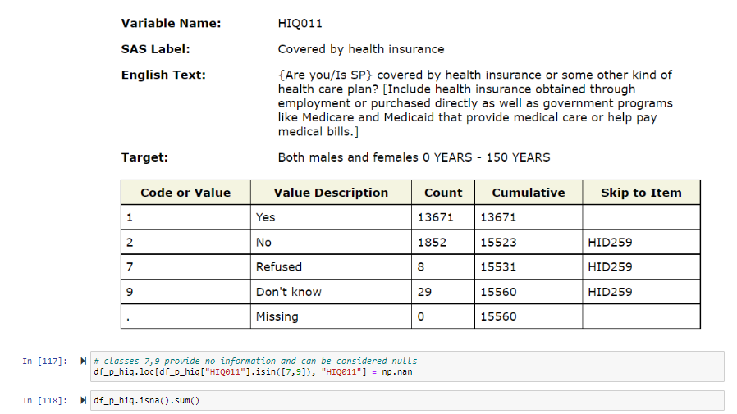

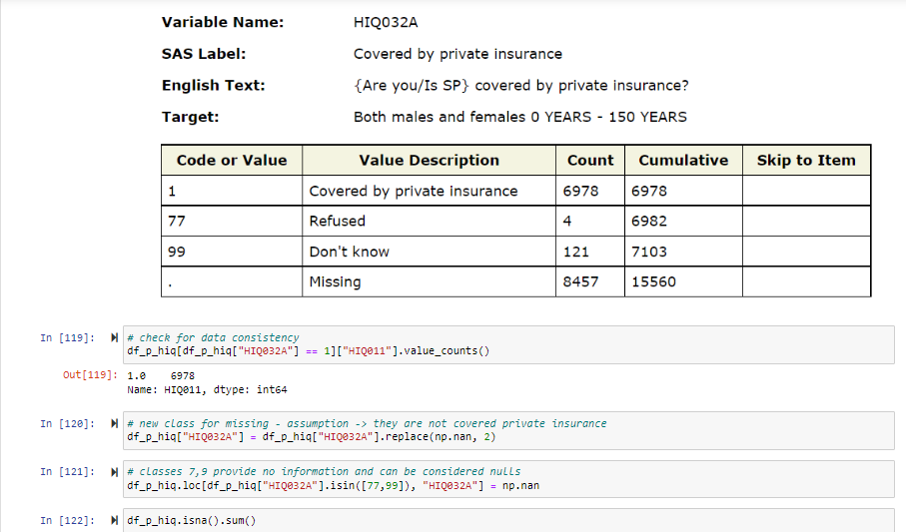

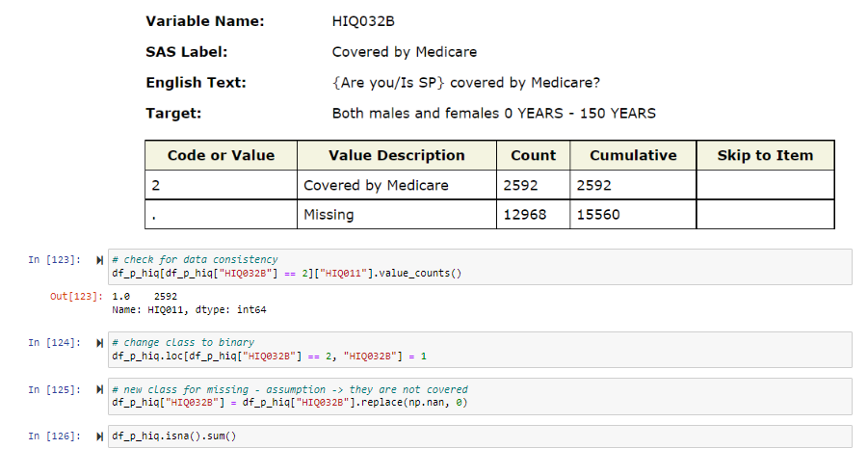

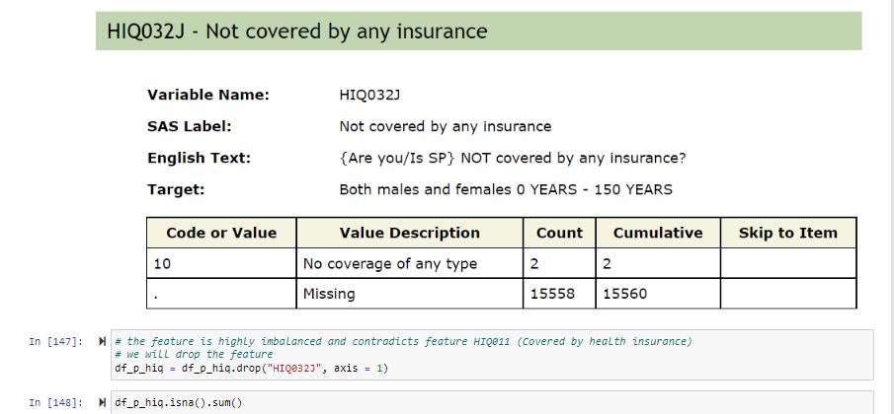

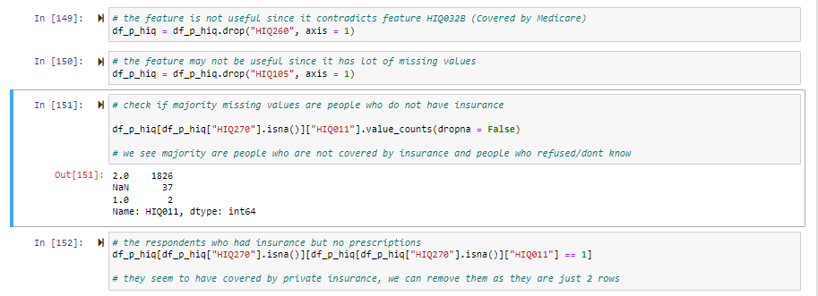

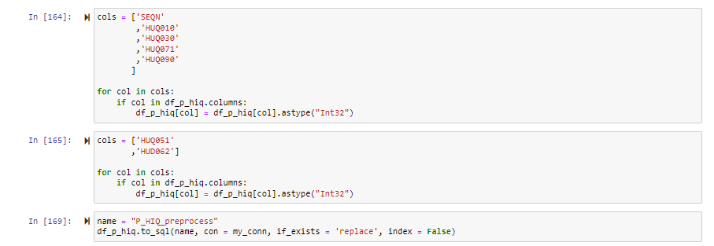

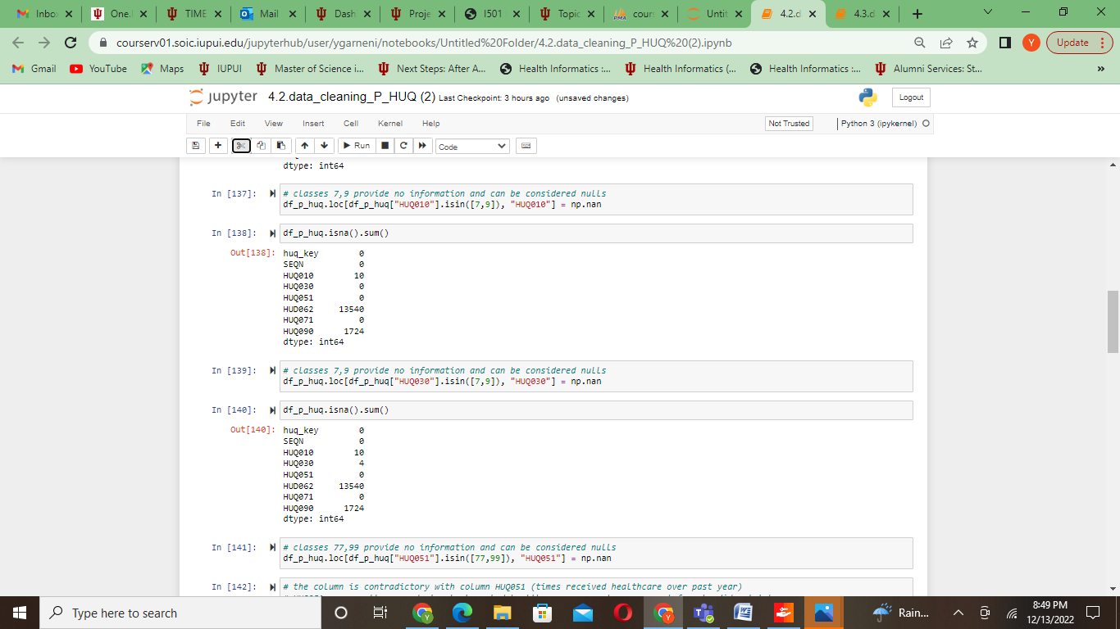



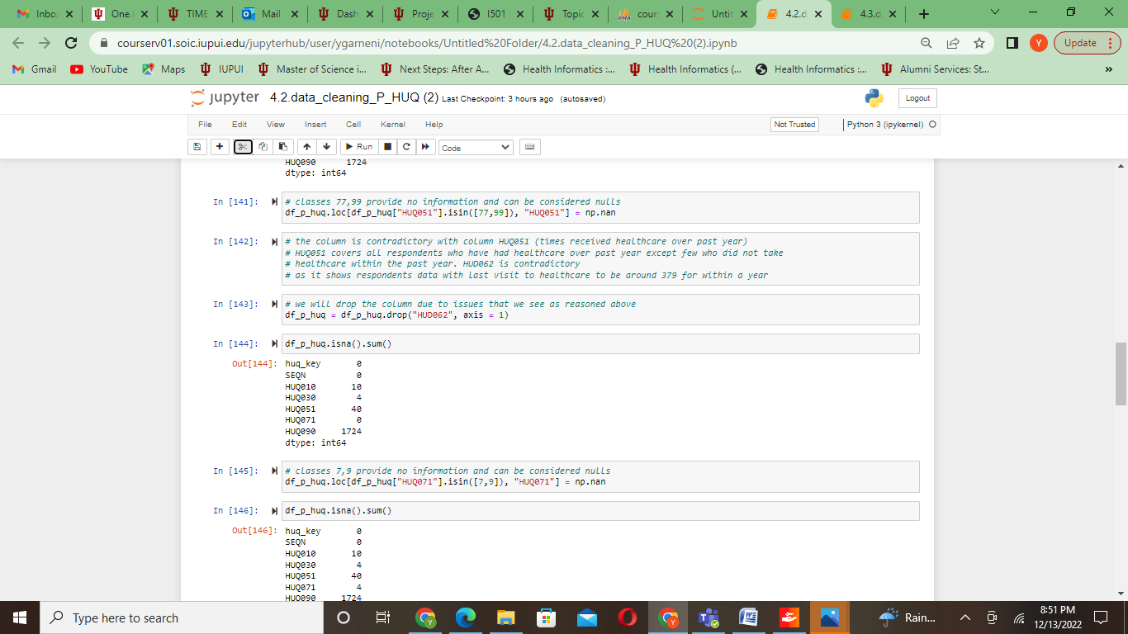



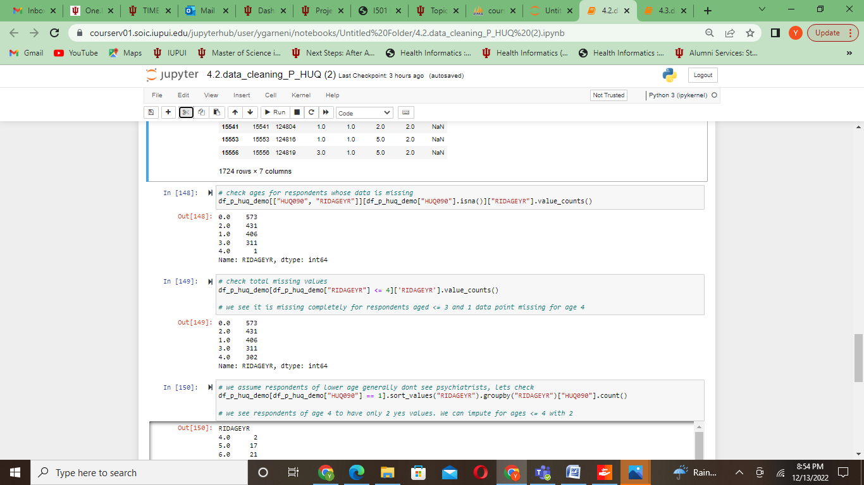

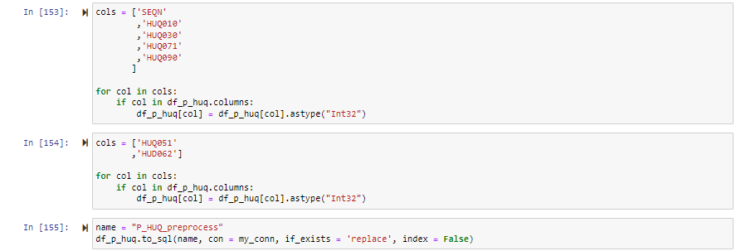

**# Data merging:**

